**INTEGRATED COMMUNITY DISPENSARY MANAGEMENT SYSTEM**

***BRIAN KIPROP KIPTALAM***

***SCT121-C007-0039/2021***

PROJECT SUBMITTED TO THE DEPARTMENT OF INFORMATION TECHNOLOGY IN THE SCHOOL OF COMPUTING AND INFORMATION TECHNOLOGY IN PARTIAL FULFILLMENT OF THE REQUIREMENT FOR THE AWARD OF DIPLOMA IN INFORMATION TECHNOLOGY IN JOMO KENYATTA UNIVERSITY OF AGRICULTURE AND TECHNOLOGY

December, 2022

# **DECLARATION**

This System project is my original work and has not been presented for a diploma in any other University or any other award.

Name: Date:

***BRIAN KIPROP KIPTALAM***

Registration Number: Signature:

***SCT121-C007-0039/2021***

**SUPERVISOR**

This System Project has been submitted for examination with my approval as University Supervisor

Signature: Date:

***DR Stephen Waweru***

*Department of Information Technology*

# **CERTIFICATION**

This is to certify that the Integrated Community Dispensary Management System is submitted by Brian Kiprop Kiptalam under the supervision of Dr Stephen Waweru in the academic of Diploma in Information Technology.

***Dr Stephen Waweru***

Sign:

Date:

*Supervisor and head of department of Information Technology*

# **DEDICATION**

I dedicate this project to Almighty God my creator, my source of inspiration, wisdom, knowledge and understanding. He has been the source of my strength throughout this project. I also dedicate this work to my Mother Dinah Karani and to my all my friends who have encouraged me all the way and encouraged me that I give it all to this project. Thank you so much. My love for you all can never be quantified. God bless you

# **ACKNOWLEDGEMENT**

I would like to express my deep gratitude and thanks to everyone who helped and supported me during the completion of this project. First, I would like to thank God and acknowledge Jomo Kenyatta University of Agriculture and Technology Department of Information Technology for providing the course and an enabling environment that helped me complete different chapters of this project. I especially thank my supervisor Dr Stephen Waweru for helping, guiding, and supporting me throughout the project to completion in partial fulfillment for the requirement of the award of Diploma in Information Technology of Jomo Kenyatta University of Agriculture and Technology. I would like to thank my family members for their constant and unrelenting support towards my university education and for their impartial love throughout

# **ABSTRACT**

The Purpose of the project “*INTEGRATED COMMUNITY DISPENSARY MANAGEMENT SYSTEM*“isto computerize the front office management of a dispensary to develop software which is user friendly simple, fast, and cost-effective. It deals with the collection of patient’s information, diagnosis details, etc. Traditionally, it was done manually. The main function of the System is register and store patient details and Employee Details and retrieve these details as and when required, and also to manipulate these details meaningfully System input contains patient details, while system output is to get these details on to the screen. The Dispensary Management System can be entered using a username and password for authorized used only such as the dispensary admin. Thesystem is accessible by a receptionist, few doctors &Nurses and an Accountant whom they will not be given access to check the dispensary reports as they will not have a valid credentials (Username and Password). Only they can add data into the database. The data are well protected for personal use and makes the data processing very fast.

**TABLE OF CONTENTS**

**DECLARATION** ii

**CERTIFICATION** iii

**DEDICATION** iv

**ACKNOWLEDGEMENT** v

**ABSTRACT** vi

**TABLES OF FIGURES** - 1 -

**CHAPTER ONE** - 2 -

**1.1** **Background Information** - 2 -

**1.2** **Problem Statement** - 3 -

**1.3** **Justification of the System** - 4 -

**1.4** **Objectives** - 4 -

**1.4.1** **General Objectives** - 4 -

**1.4.2** **Specific Objectives** - 4 -

**1.5** **Proposed System** - 5 -

**1.6** **Functional Requirements** - 5 -

**CHAPTER TWO** - 7 -

**LITERATURE REVIEW** - 7 -

**2.1** **Introduction** - 7 -

**2.2** **Case Studies of Similar Systems** - 7 -

**2.3** **Research Gaps** - 8 -

**CHAPTER THREE** - 9 -

**RESEARCH METHODOLOGY** - 9 -

**3.1** **Introduction** - 9 -

**3.2** **Software Process Model Adopted** - 9 -

**3.2.1** **Strengths** - 10 -

**3.2.2** **Weaknesses** - 11 -

**3.3** **Requirement Gathering Tools** - 11 -

**3.4** **System Requirements** - 11 -

**3.4.1** **Hardware Requirements** - 11 -

**3.4.2** **Software Requirements** - 12 -

**CHAPTER FOUR** - 13 -

**SYSTEM ANALYSIS AND DESIGN** - 13 -

**4.1** **Introduction** - 13 -

**4.2** **Requirement Analysis** - 13 -

**4.2.1** **Functional Requirements** - 13 -

**4.2.2** **Nonfunctional Requirements** - 14 -

**4.3** **UML Design** - 14 -

**4.4** **UML Approach** - 15 -

**CHAPTER FIVE** - 24 -

**SYSTEM IMPLEMENTATION AND TESTING** - 24 -

**5.0** **INTRODUCTION** - 24 -

**5.1** **Summary of the Modules** - 24 -

**5.1.1** **Login Module** - 24 -

**5.1.2** **Admin module** - 24 -

**5.1.3** **Doctor** - 24 -

**5.1.4** **Nurse** - 24 -

**5.1.5** **Lab In charge** - 24 -

**5.1.6** **Pharmacist** - 24 -

**5.2** **Summary of how the System works** - 25 -

**5.3** **Testing Regime** - 37 -

**5.3.1** **Tabulation of the test conducted** - 37 -

**5.3.2** **Screenshot of the test** - 37 -

**CHAPTER SIX** - 38 -

**SYSTEM IMPLEMENTATIONS** - 38 -

**6.0** **Introduction** - 38 -

**6.1** **Coding and testing** - 38 -

6.2 About the language - 41 -

**6.3** **Features of Visual Basic for Applications** - 42 -

**6.4** **About the tools** - 43 -

**7** **CHAPTER SEVEN** - 44 -

**CONCLUSIONS AND RECOMMENDATIONS** - 44 -

**7.1** **Conclusion** - 44 -

**7.2** **Recommendations** - 44 -

**8** **REFERENCES** - 45 -

**9** **APPENDICES** - 46 -

**9.1** **APPENDIX 1: WORKPLAN** - 46 -

**9.2** **APPENDIX 2: System Codes** - 47 -

**9.3** **APPENDIX 3: QUESTIONNAIRES** - 56 -

# **TABLESOF FIGURES**

**Figure 1: Software process model adopted - 10 -**

**Figure 2: Use case diagram - 17 -**

**Figure 3: Class Diagram - 18 -**

**Figure 4:Sequence diagram - 19 -**

**Figure 5: Collaboration Diagram - 20 -**

**Figure 6:Deployment diagram - 20 -**

**Figure 7:Patient’s Flowchart - 21 -**

**Figure 8:Employee Flowchart - 22 -**

**Figure 9:Admin Flowchart - 23 -**

**Figure 10: Login Module - 37 -**

**Figure 11: Workplan - 46 -**

# **CHAPTER ONE**

## **Background Information**

In Kenya, a dispensary is a small health facility, usually managed by registered medical personnel for example, Doctor or a nurse. It provides the most basic primary healthcare services to rural communities e.g., childhood immunization, family planning, some laboratory test among other services. The nurses report to the nursing officer at the health center, where they refer patients with complicated diseases to be managed by clinical officer.

The Project Integrated Community Dispensary Management System includes registration of patients, storing their details into the system, and also computerized billing in the pharmacy, and labs. The software has the facility to give a unique id for every patient and stores the details of every patient and the staff automatically. It includes a search facility to know the current status of each room.

The Integrated Community Dispensary Management System can be entered using a username and password which is only accessible either by an admin who can add new employee user accounts, whom they will be regarded as “Other Admin”, these are the only ones who can check the Dispensary’s Report.

System users such as Admin, Doctors, Nurses, Receptionist and Accountant can add data into the database. The data can be retrieved easily. The interface is very user-friendly. The data are well protected for personal use and makes the data processing very fast. Community Dispensary Management System is powerful, flexible and easy to use and is designed for multispecialty hospitals, to cover a wide range of dispensary administration and management processes. It is an integrated end-to-end Dispensary Management System that provides relevant information across the dispensary to support effective decision making for patient care, Dispensary administration and critical financial accounting, in a seamless flow. Dispensary Management System is a software product suite designed to improve the quality and management of Dispensary management in the areas of clinical process analysis and activity-based costing. Dispensary Management system enables you to develop your organization and improve its effectiveness and quality of work.

## **Problem Statement**

Currently many Hospitals and Dispensaries in Kenya stores their files in shelves at the registry office where it’s at high risk to access and tamper with the patient or other important information files that show the day-to-day activities of the organization. The files can be prone to fire and even other damages like the papers can been tore.

Kapkures Dispensary currently uses a manual system for the management and maintenance of critical information. The current system requires numerous paper forms, with data stores spread throughout the dispensary infrastructure. Often information is incomplete or does not follow management standards. Forms are often lost in transit between departments requiring a comprehensive auditing process to ensure that no vital information is lost. Multiple copies of the same information exist in the dispensary and may lead to inconsistencies in data in various data stores. Other problem statementsare:

**Lack of immediate retrievals: -**

The information is very difficult to retrieve and to find particular information like- E.g. – To find out about the patient’s history, the user has to go through various registers. This results in inconvenience and wastage of time.

**Lack of immediate information storage: -**

The information generated by various transactions takes time and efforts to be stored at right place.

**Lack of prompt updating: -**

Various changes to information like patient details are difficult to make as paper work is involved.

**Error prone manual calculation: -**

Manual Calculations are error prone and take a lot of time this may result in incorrect information. For example, calculation of patient’s bill based on various treatments.

**Preparation of accurate and prompt reports: -**

This becomes a difficult task as information is difficult to collect from various register.

The project seeks to control and allow registration of all information related to the dispensary activities, this is to enhance reduction of time and eliminating manual works. This work of this system is to deliver a function that will provide benefits to the dispensary. The benefits include more efficiency entry of data, data efficient retrieval and efficient data storage.

## **JustificationoftheSystem**

Automated dispensary files storage process will be less time consuming and thus speeding up the processing of serving the dispensary patient’s.

## **Objectives**

### **General Objectives**

To design and implement an efficient and interactive system for the Dispensary admin and other dispensary employees.

### **Specific Objectives**

* Providing accurate, up-to-date, and complete information about patients at the point of care
* Enabling quick access to patient records for more [coordinated, efficient care](https://www.healthit.gov/providers-professionals/improved-care-coordination)
* Securely sharing electronic information with patients and other clinicians
* Helping providers more effectively [diagnose patients, reduce medical errors, and provide safer care](https://www.healthit.gov/providers-professionals/improved-diagnostics-patient-outcomes)
* Improving patient and provider interaction and communication, as well as [health care convenience](https://www.healthit.gov/providers-professionals/health-care-quality-convenience)
* Helping promote legible, complete documentation and accurate, streamlined coding and billing
* Enhancing privacy and security of patient data
* Enabling safer, more reliable prescribing
* Helping providers improve productivity and work-life balance
* Enabling providers to improve efficiency and meet their [business goals](https://www.healthit.gov/providers-professionals/faqs/how-will-using-electronic-health-records-ehr-improve-providers%E2%80%99-busines)
* Reducing costs through decreased paperwork, improved safety, reduced duplication of testing, and improved health.

## **Proposed System**

1) **Improved Manual System**- One of the alternative solutions is the improvement of the manual system. Anything, which can be done by using automated methods, can be done manually. But the question arises how to perform thing manually in a sound manner. Following are some suggestions, which can be useful in the manual system. A more sophisticate register maintenance for various Patient Information, Doctor diary, Immunization Details and a good system for writing bill amount employees and stock availed for the customers can be maintained at central place. Adequate staff may be maintained so that updations are made at the very moment at the same time. Proper person for proper work should be made responsible so that a better efficiency could be achieved. This needs a lot of work force.

2) **OnlineSystem**- This system provides online storage/ updations and retrieval facility. This system promises very less or no paper work and also provides help to Doctor and operational staff. In this system everything is stored electronically so very less amount of paper work is required and information can be retrieved very easily without searching here and there into registers.

## **FunctionalRequirements**

* **Login Module:** This shall be developed to have a centralized rights and authentication facility to ensure only authorized users have access to the system providing a security standard to protect vital information.
* **A Database Facility:** This shall be developed to store, files, information about users, (date, Doctors, patients, new employees etc.)
* **Manager of the Health Center:** View daily reports, attendance and leaving time from the health center staffs.
* **Admin:** Manage department of the health center, watch medicine status of hospital stock and watch the operation report of the health center.
* **Doctor:** Manage patient. Account opening and updating the status of a patient and create prescription for patient.
* **Nurse:**Provide medication according to patient prescription.
* **Lab In charge:** Upload diagnostic report.
* **Pharmacist:**Get a notification from the doctor digitally about a prescription to be issued to a patient.

# **CHAPTER TWO**

# **LITERATURE REVIEW**

## **Introduction**

Integrated Community dispensary management system is a computerized medical information system that collects, stores and displays patient information. They are a means to create legible and organized patient data and to access clinical information about individual patients. Integrated Community dispensary management system is intended to complement existing (often paper-based) medical records which are already familiar to practitioners. Patient records have been stored in paper form for centuries and, over this period of time; they have consumed increasing space and notably delayed access to efficient medical care. In contrast, Integrated Community dispensary management system store individual patient clinical information electronically and enable instant availability of this information to all providers in the healthcare chain and so assist in providing coherent and consistent care.

## **Case Studiesof Similar Systems**

This would likely focus on the effectiveness and efficiency of such systems in improving patient care and reducing costs.

One study, published in the journal of Medical Systems, found that implementing a dispensary management system in a hospital setting significantly improved medication dispensing accuracy and reduced medication errors.

Another study, published in the journal of the American medical informatics Association, found that implementing a dispensary management system in a primary care setting improved patient satisfaction and increased the efficiency of the dispensing process.

Additionally, several studies have also found that dispensary management systems can help reduce costs and improve financial performance in health care organizations. For example, a study published in the journal of medical economics found that implementing a dispensary management system in a hospital setting led to significant cost savings due to increased efficiency and reduced medication waste.

Overall, the literature suggests that dispensary management systems can be effective in improving patient care and reducing costs in health care organization.

## **Research Gaps**

A literature review on a dispensary Management system found that there are several gaps in research on this topic.

Firstly, there is a lack of studies focused on the effectiveness of dispensary management systems in improving patient care and outcomes. While some studies have shown that these systems can improve efficiency and reduce errors, there is need for more rigorous research to demonstrate their impact on patient outcomes.

Secondly, there is a lack of research on the integration of dispensary management systems with other healthcare systems and technologies. As the healthcare industry becomes increasingly digitized, there is a need for research on how dispensary management systems can integrate with electronic medical records and other technologies to improve patient care and outcomes.

# **CHAPTER THREE**

# **RESEARCH METHODOLOGY**

## **Introduction**

This chapter presents the software process model used and the strengths and weaknesses of the model used. The required tools to be used in system creation and the system requirements are needed to make that system. The system requirements are the software requirements and the hardware requirements.

## **Software Process Model Adopted**

The nature of the project recommended agile model of System Development Life Cycle

(SDLC). The agile model process starts with a simple implementation of a subset of the

Software requirements and iteratively enhances the evolving versions until the full system is implemented. The agile methodology gives the need to develop a system based on the requirements of the users, and enable to add up various units of the system pertaining the various feedbacks received from the users. At each iteration and increment, design modifications are made and new functional capabilities are added. And the phases include; Identifying Problems, Opportunities

and Objectives, Determine Human Information Requirement, Analyzing System Needs, designing the Recommended System, Developing and Documenting Software, Testing and Maintenance of the system.



Figure 1: Software process model adopted

Source (<https://www.tutorialspoint.com/sdlc/sdlc_agile_model.htm>)

### **Strengths**

* Is a very realistic approach to software development.
* Promotes teamwork and cross training.
* Functionality can be developed rapidly and demonstrated.
* Resource requirements are minimum.
* Suitable for fixed or changing requirements
* Delivers early partial working solutions.
* Good model for environments that change steadily.
* Minimal rules, documentation easily employed.
* Enables concurrent development and delivery within an overall planned context.
* Little or no planning required.
* Easy to manage.
* Gives flexibility to developers.

### **Weaknesses**

• More risk of sustainability, maintainability and extensibility.

• Difficult planning at early stages. Planning in Agile development is essential before the process is started.

• Depends heavily on customer interaction, so if customer is not clear, team can be driven in the wrong direction.

## **Requirement Gathering Tools**

General observation and making a tour to the Kapkures Health center to ask some questions about their current system and what they can propose to the system I will be developing.

## **System Requirements**

These are the configuration that a system must have in order for a hardware or software application to run smoothly and efficiently.

### **Hardware Requirements**

The most common set of requirements defined by any operating system or software application is the physical computer resources, also known as hardware. A hardware requirements list is often accompanied by a hardware compatibility list (HCL), especially in case of operating systems. An HCL, lists tested, compatibility and sometimes incompatible hardware devices for a particular operating system or application. The following sub-sections discuss the various aspects of hardware requirements.

**HARDWARE REQUIREMENTS FOR PRESENT PROJECT:**

PROCESSOR : Intel(R) Core (TM) i3

RAM : 4GB

HARDDISK : 500GB

### **Software Requirements**

Software Requirements deal with defining software resource requirements and pre-requisites that need to be installed on a computer to provide optimal functioning of an application. These requirements or pre-requisites are generally not included in the software installation package and need to be installed separately before the software is installed.

**SOFTWARE REQUIREMENTS FOR PRESENT PROJECT:**

OPERATING SYSTEM : Windows 10

FRONT END : Microsoft Access

SERVER-SIDE SCRIPT : Visual Basic

DATABASE : Access Database

# **CHAPTER FOUR**

# **SYSTEM ANALYSIS AND DESIGN**

## **Introduction**

This chapter tackles the approaches that I used to achieve the objective of the project. It also demonstrates mainly the techniques to be used to capture user requirements and specification.

## **Requirement Analysis**

A requirement is a formal definition for the functionality of a system. It contains conditions about the performance and functionality of the entire system. The functionality can be classified into two main groups;

• Functional Requirement

• Nonfunctional Requirement

### **Functional Requirements**

The functional requirement describes how the system will work in terms of its inputs, the behavior, and outputs. The functional requirements are:

* **Login Module:** This shall be developed to have a centralized rights and authentication facility to ensure only authorized users have access to the system providing a security standard to protect vital information.
* **A Database Facility:** This shall be developed to store, files, information about users, (date, Doctors, patients, new employees etc.)
* **Manager of the Health Center:** View daily reports, attendance and leaving time from the health center staffs.
* **Admin:** Manage department of the health center, watch medicine status of hospital stock and watch the operation report of the health center.
* **Doctor:** Manage patient. Account opening and updating the status of a patient and create prescription for patient.
* **Nurse:** Provide medication according to patient prescription.
* **Lab In charge:** Upload diagnostic report.
* **Pharmacist:** Get a notification from the doctor digitally about a prescription to be issued to a patient.

### **Nonfunctional Requirements**

Non-functional requirement describes how a system should behave and what limits there are on

Its functionality.

* **Performance:** The system shall allow several user registrations at the same time without downgrading performance.
* **Availability:** The system shall be available to all access areas in the dispensary.
* **Usability:** The system shall be easy to learn and use by allEmployees who will be given access to by the dispensary admin.
* **Reliability:** The system has low system failure occurrence and low risk. And will not take much time to resolve it.
* **Accuracy:** The system shall work accurately without high failure or error.
* **Security:** The system shall allow employees with assigned user names and passwords. The system shall be designed to make it impossible for unauthorized people to login without valid usernames or password

## **UML Design**

The Unified Modeling Language (UML) is a standard language for specifying, visualizing, constructing and documenting the software system and its system and its components. It is a graphical language, which provides a vocabulary and set of semantics and rules. The UML focuses on the conceptual and physical representation of the system. It captures the decisions and understandings about systems that must be constructed. It is used to understand, design, configure, maintain and control information about the systems.

The UML is a language for:

* Visualizing
* Specifying
* Constructing
* Documenting

**Visualizing**

Through UML, we see or visualize an existing system and ultimately, we visualize how the system is going to be after implementation. Unless we think, we cannot Implement. UML helps to visualize, how the components of the system communicate and interact with each other.

**Specifying**

Specifying means building, models that are precise, unambiguous and complete UML addresses the specification of all the important analysis design, implementation decisions that must be made in developing and deploying a software system.

**Constructing**

UML models can be directly connected to a programming language like JAVA or C++ or VB. Forward Engineering and Reverse Engineering is possible through UML.

**Documenting**

The deliverables of a project apart from coding are some artifacts, which are critical in controlling, measuring and communicating about a system during its developing requirements, architecture, desire, source code, project plans, tests, prototypes releasers etc...

## **UML Approach**

**UML Diagram**

A diagram is a graphical presentation of a set of elements, most often rendered as a connected graph of vertices and arcs, you draw diagram to visualize a system from different perspective, so a diagram is a projection into a system. For all but most trivial systems, a diagram represents an elided view of the elements that make up a system. The same element may appear in all diagrams, only a few diagrams, or in no diagrams at all. In theory, a diagram may contain any combination of things and relationships. In practice, however, a small number of common combinations arise, which are consistent with the five most useful views that comprise the architecture of a software-intensive system. For this reason, the UML includes nine such diagrams:

1. Class diagram
2. Object diagram
3. Use case diagram
4. Sequence diagram
5. Collaboration diagram
6. State chart diagram
7. Activity diagram
8. Component diagram
9. Deployment diagram

**USE CASE DIAGRAM:**

A use case diagram in the Unified Modeling Language (UML) is a type of behavioral diagram defined by and created from a use-case analysis. Its purpose is to present a graphical overview of the functionality provided by a system in terms of actors, their goals (represented as use cases), and any dependencies between those use cases.

Use case diagrams are formally included in two modeling languages defined by the Unified Modeling Language (UML) and the systems Modeling Language (sysML)

**Use case** diagram of my project:



Admin

Doctors & Staff

Figure 2: Use case diagram

**Class Diagram:**

A class is a category or group of things that has similar attributes and common behavior. A Rectangle is the icon that represents the class it is divided into three areas. The upper most area contains the name, the middle; area contains the attributes and the lowest areas show the operations. Class diagrams provides the representation that developers work from. Class diagrams provides the representation that developers work from. Class diagrams help on the analysis side, too.

Dispensary

+name_string

+address_string

+phon_number

+name_string

+age_number

+date of birth_number

+phone num_number

+gender_string

Person

+available time ()

+location ()

+date of join ()

Staff

+joined: date

+qualification_string

+certification_string

+gender_string

+prescription_string

+symptoms_string

Patient

+work duties ()

+current_Date ()

Technical staff

Admin Staff

+name_string

+location_string

Operations Staff

+name of emp_string

+details_string

+join time ()

+join time ()

+names_string

+deprt_string

+room_num ()

+test time ()

+mdc_stock ()

+in time ()

+ot_time ()

+join date ()

+join date ()

+patient_details

+age_number

+name_string

+test_details

+time_number

+name_string

+address_string

+deprt_string

+name_string

+address_string

+phon_number

+name_string

+address_string

+phon_number

+speciality_string

Laboratorist

Store Keeper

Receptionist

Nurse

Doctor

+open reports ()

+create emp_Acc ()

Figure 3: Class Diagram

**Sequence diagram:**

A **Sequence Diagram** is an interaction diagram that emphasis the time ordering of messages; a collaboration diagram is an interaction diagram that emphasizes the structural organization of the objects that send and receive messages. Sequence diagrams and collaboration diagrams and collaboration diagrams are isomorphic, meaning that you can take one and transform it into the other.

Discharge patient

Give procedure

to patient

Go to laboratory

Assign Medicine

Registration

Patient ok ()

Pay for Services

Give patient medicine

Account

Patient

Doctor

Discharge

Pharmacy

Laboratory

Reception

Registration

Figure 4:Sequence diagram

**Collaboration Diagram:**

A **Collaboration diagram** also called a communication diagram or interaction diagram, is an illustration of the relationships and interactions among software objects. The concept is more than a decade old although it has been refined as modeling paradigms have evolved.

1: Takes Appointment

10: Takes Appointment from doctor

4: Confirms appointment

9: Ask for payment

7: Take medicine

5: Consult doctor

8: Patient ok

3: Doctor Available

6: Assist doctor

2: takes Appointment from doctor

D1: Doctor

N1: Nurse

R1: Receptionist

P1: Patient

Figure 5: Collaboration Diagram

**Deployment diagram:**

A **Deployment diagram** shows the configuration of run-time processing nodes and the components that live on them. Deployment diagrams address the static deployment view of architecture. They are related to component diagrams in that a node typically encloses one or more components.

Figure : Deployment diagram

Database Server

Printer

Kapkures Health Center Server

Desktop Client

**State chart Diagrams:**

The state diagram shows the states of an object and represents activities as arrows connecting the states. The Activity Diagram highlights the activities. Each activity is represented by a rounded rectangle-narrower and more oval-shaped than the state icon. An arrow represents the transition from one activity to the next. The activity diagram has a starting point represented by filled-in circle, and an end point represented by bulls eye.

**Patient’s Flowchart**

Figure :Patient’s Flowchart

Input; take patient’s details

Output; patient’s details, patient result, bill for service

Accounts; provide other service, print receipts

Is patient treated in ward?

Pharmacy; give medicine

Is patient treated?

Input; temp, blood pressure, weight, height

Ward; patient’s details from lab

No

No

Yes

Yes

Lab tests

Consult; tell symptoms

Emergency

Figure :Employee Flowchart

**Employee Flowchart**

Want to live in quarters?

Are you employed?

No

Yes

Yes

Output; employee details, cost of hours

Sign attendance, leaving time

Provide details, choose a house

Provide documents on position you require

Input; Employee Details

**Admin Flowchart**

Figure :Admin Flowchart

No

Yes

Add new admin

Output; print reports

View reports

Are you a main admin?

Input; main admin, other admin

# **CHAPTER FIVE**

# **SYSTEM IMPLEMENTATION AND TESTING**

## **INTRODUCTION**

This chapter highlights the modules of the system, how the system works, testing the system, the conclusions and recommendation that I will recommend regarding the use of the system.

## **Summary of the Modules**

### **Login Module**

The login module is the module were users and admin enter the password for the system to authenticate and ensure only authorized users to access the system providing a security standard to protect vital information.

### **Admin module**

After a successful login by the Admin, the Admin can Manage department of the health center, watch medicine status of hospital stock and watch the operation report of the health center.

### **Doctor**

Manage patient. Can Login to the system and updating the status of a patient and create prescription for patient.

### **Nurse**

Provide medication according to patient prescription.

### **Lab In charge**

Upload diagnostic report.

### **Pharmacist**

Get a notification from the doctor digitally about a prescription to be issued to a patient.

## **Summaryofhow the Systemworks**

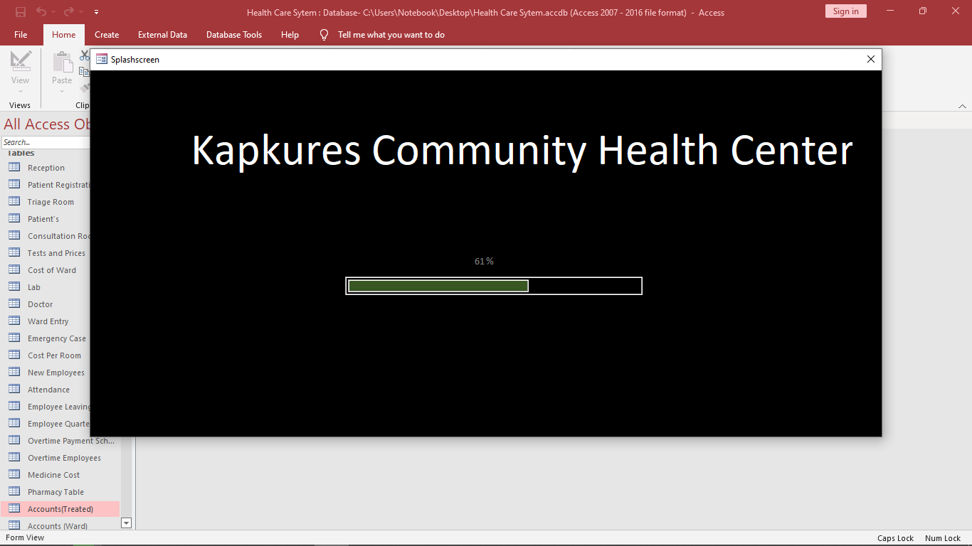

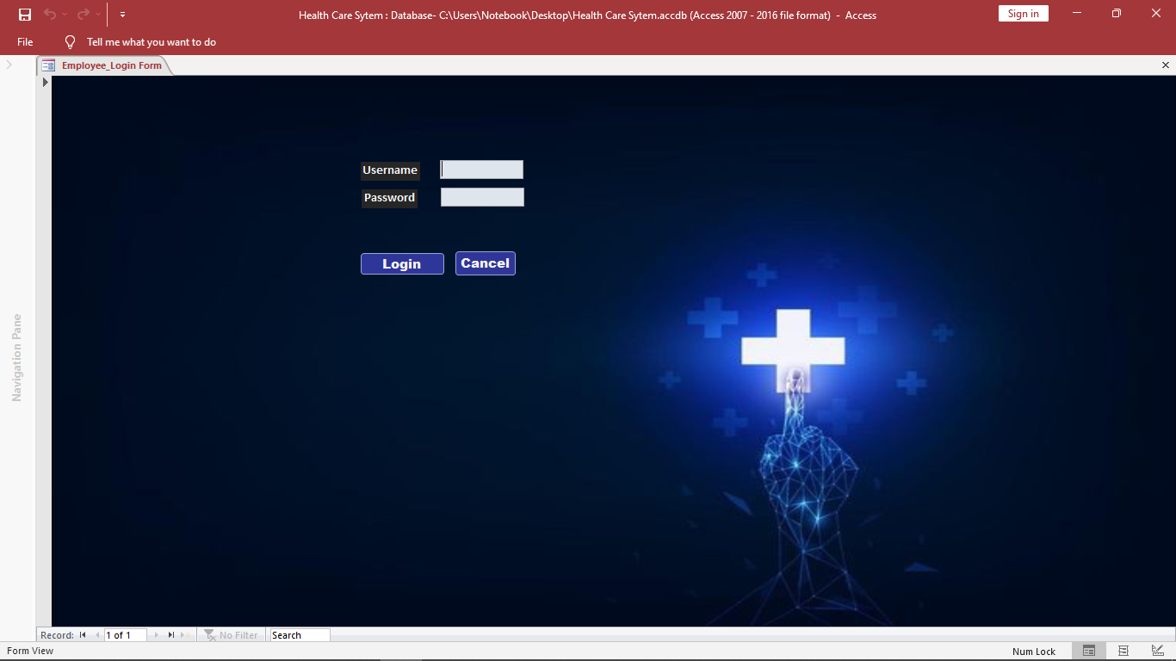

**Patient Section**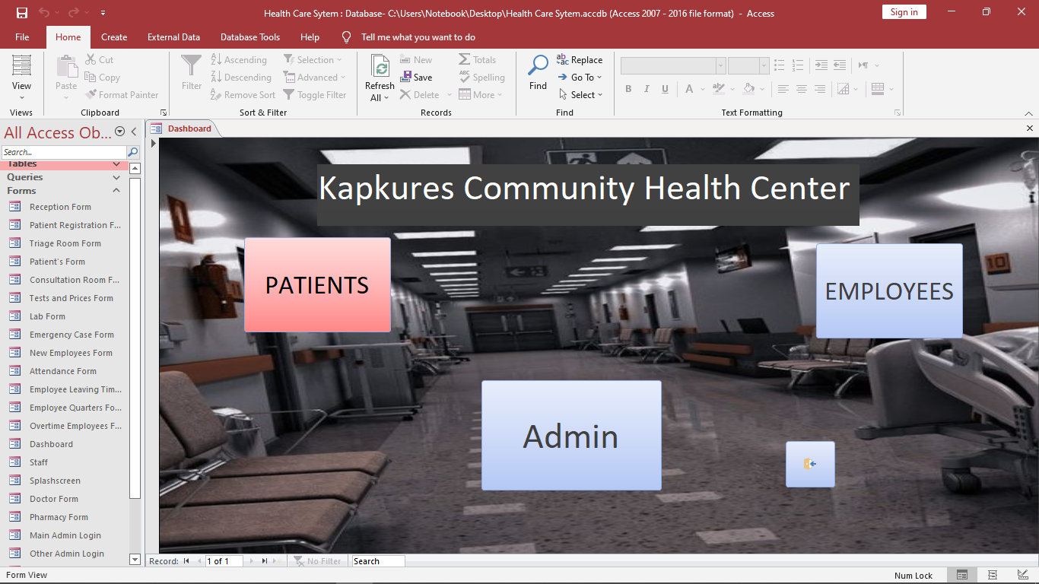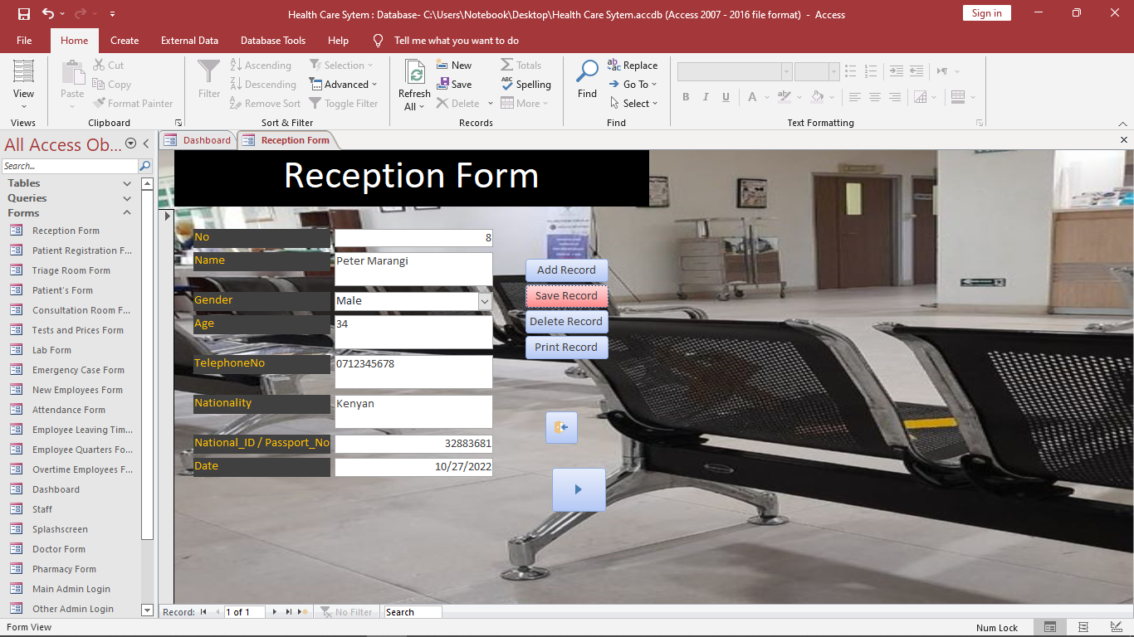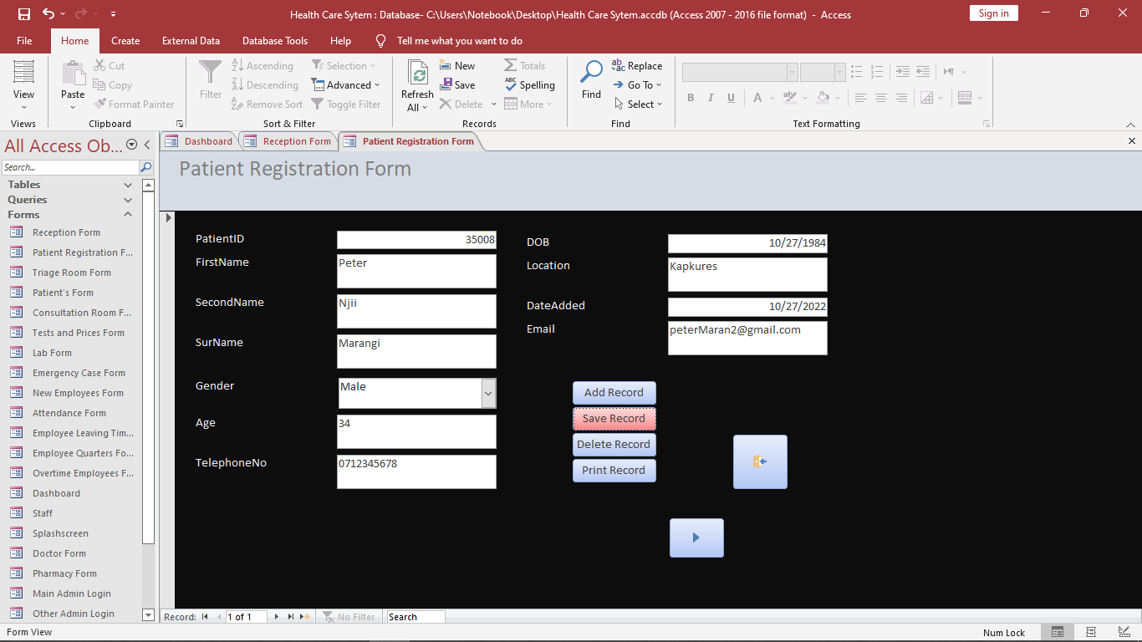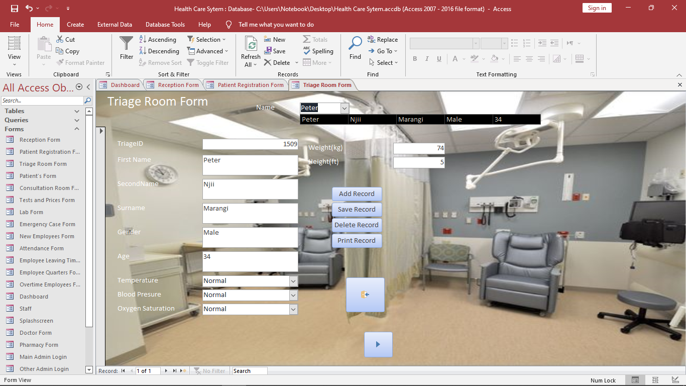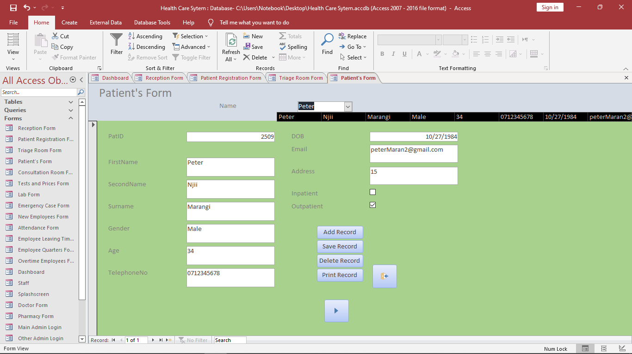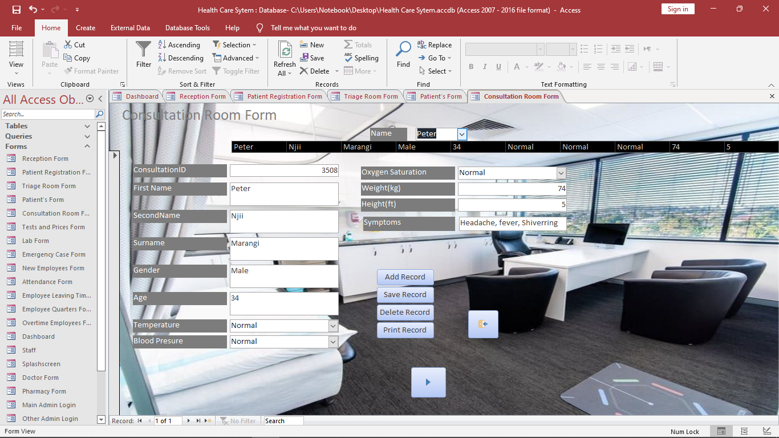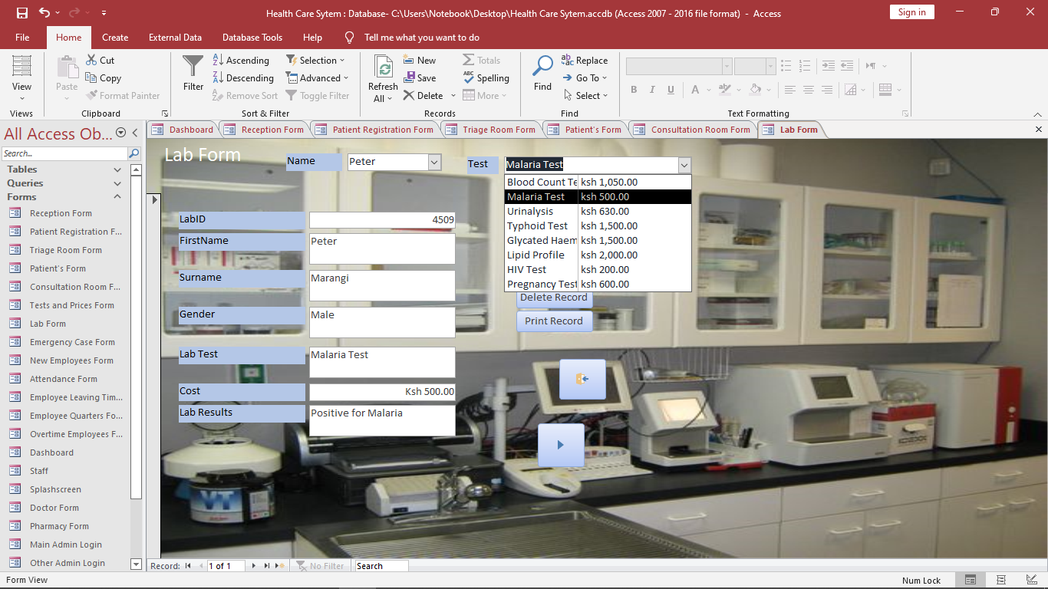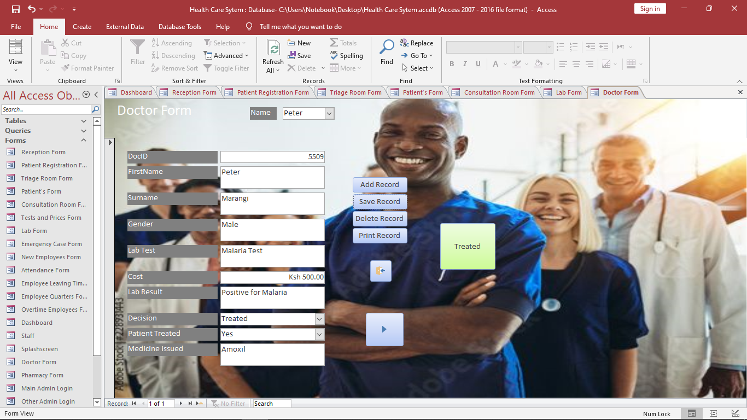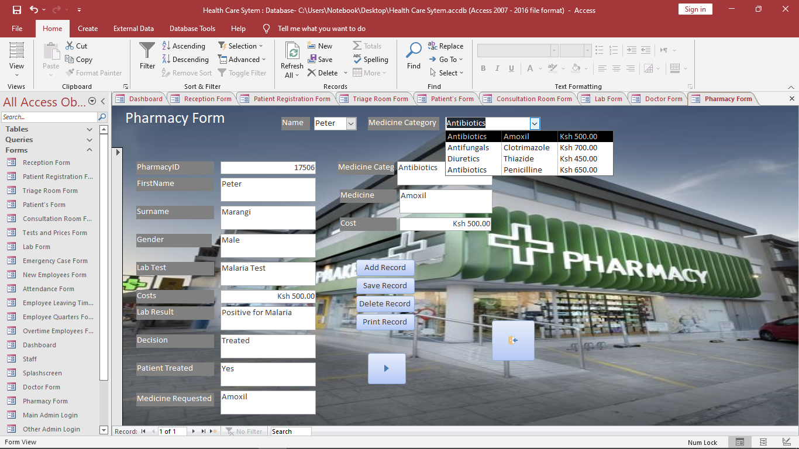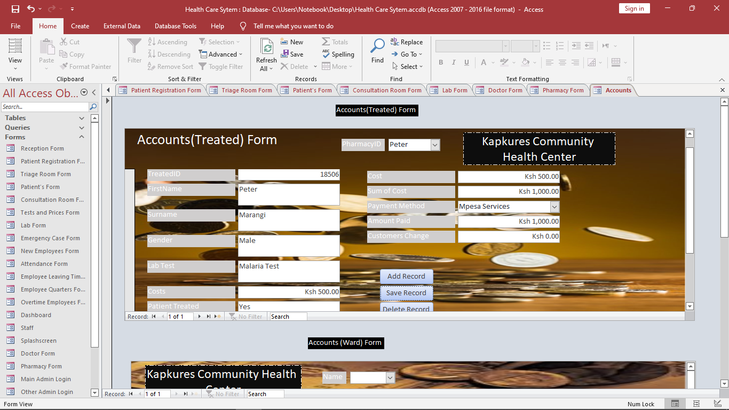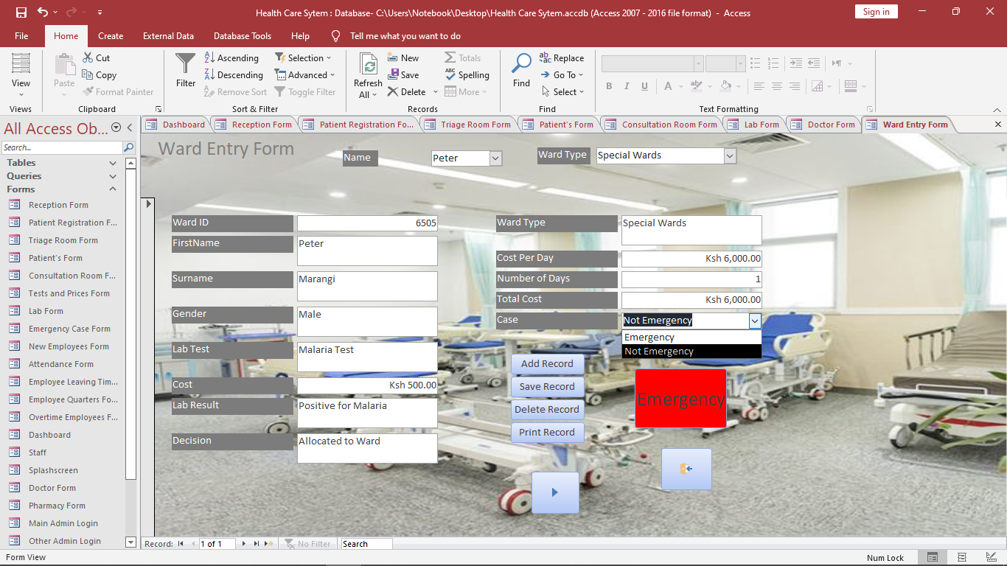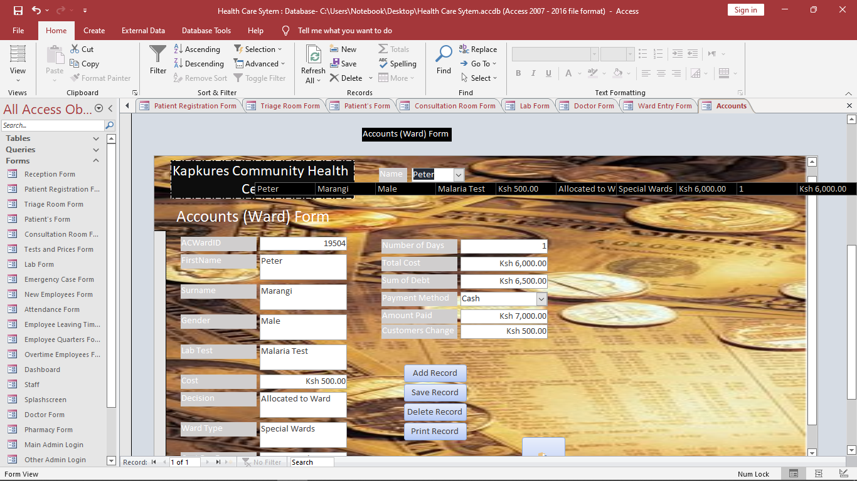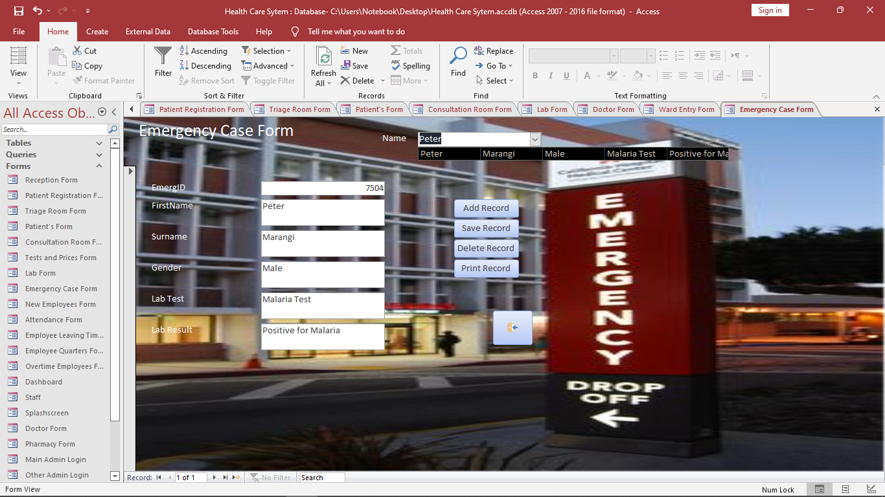

**Employee Section**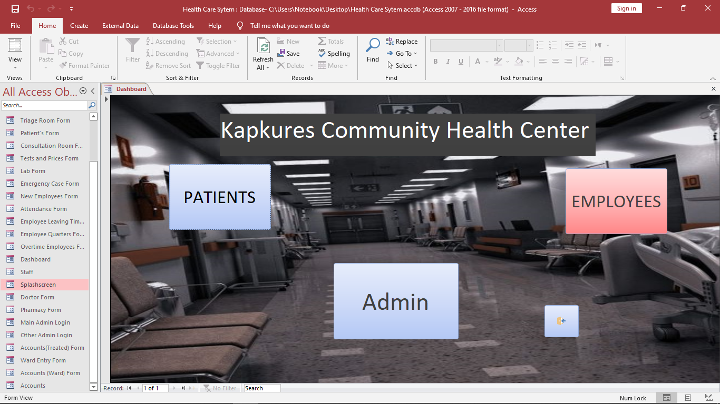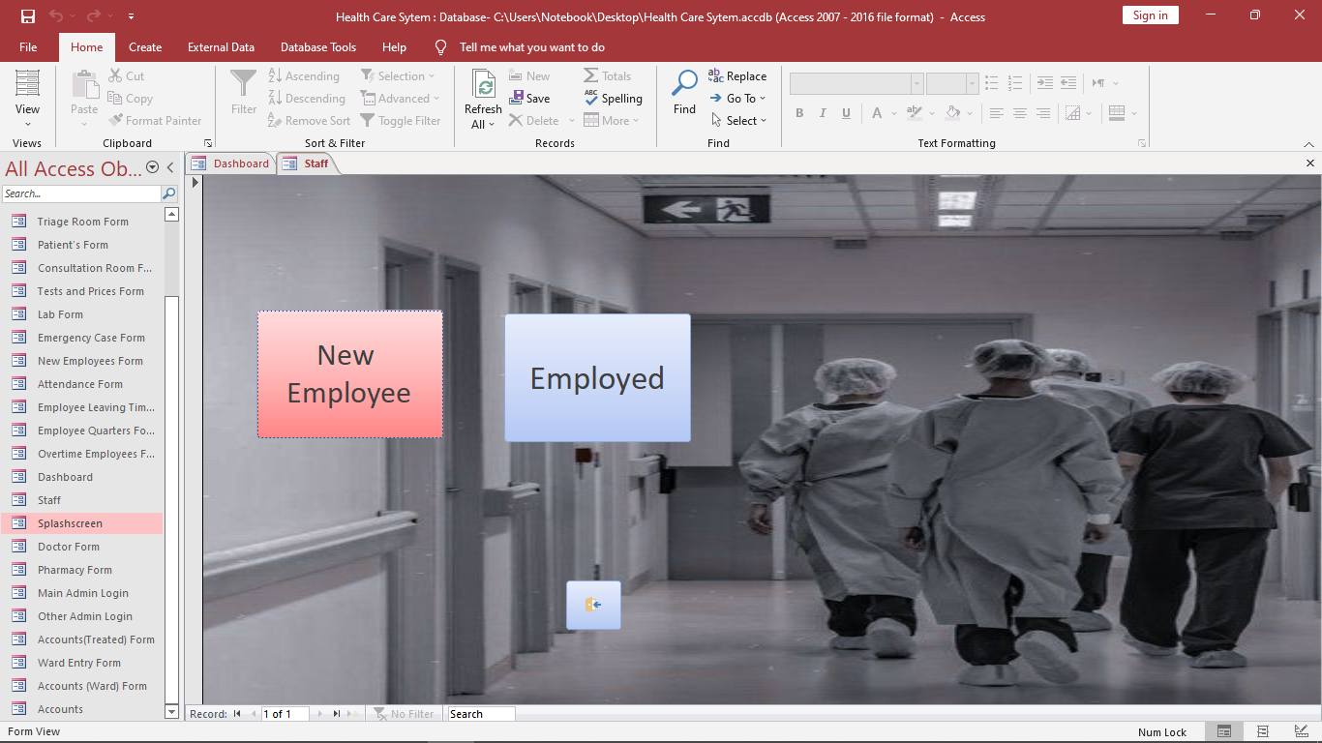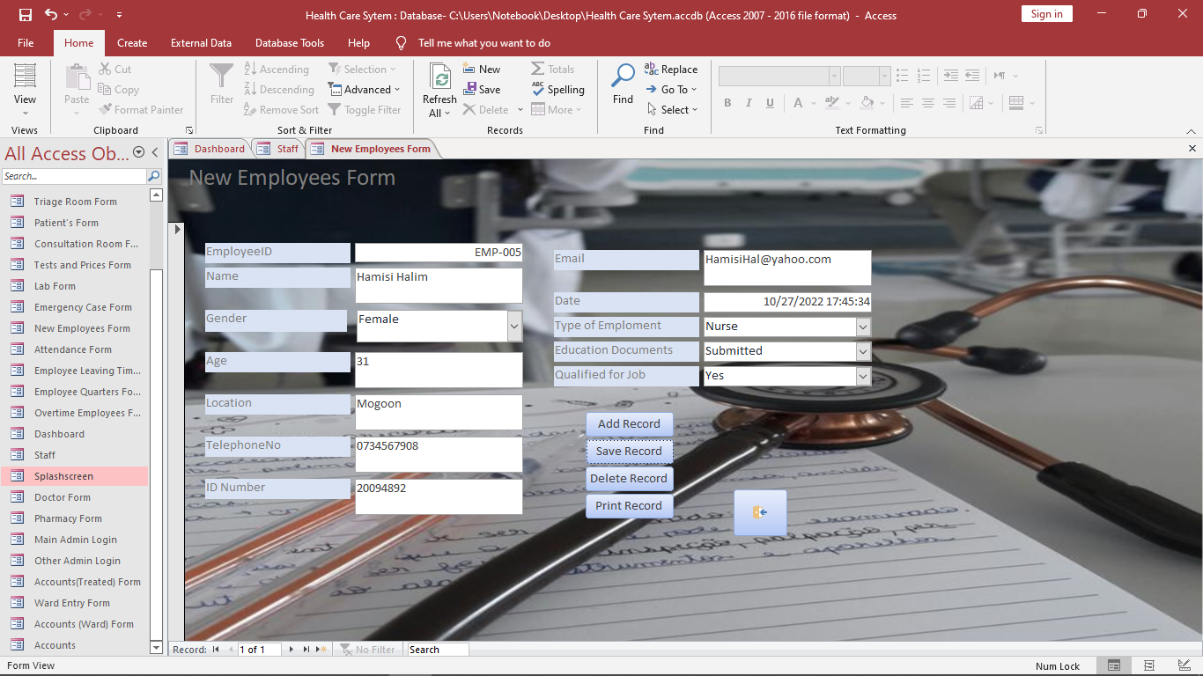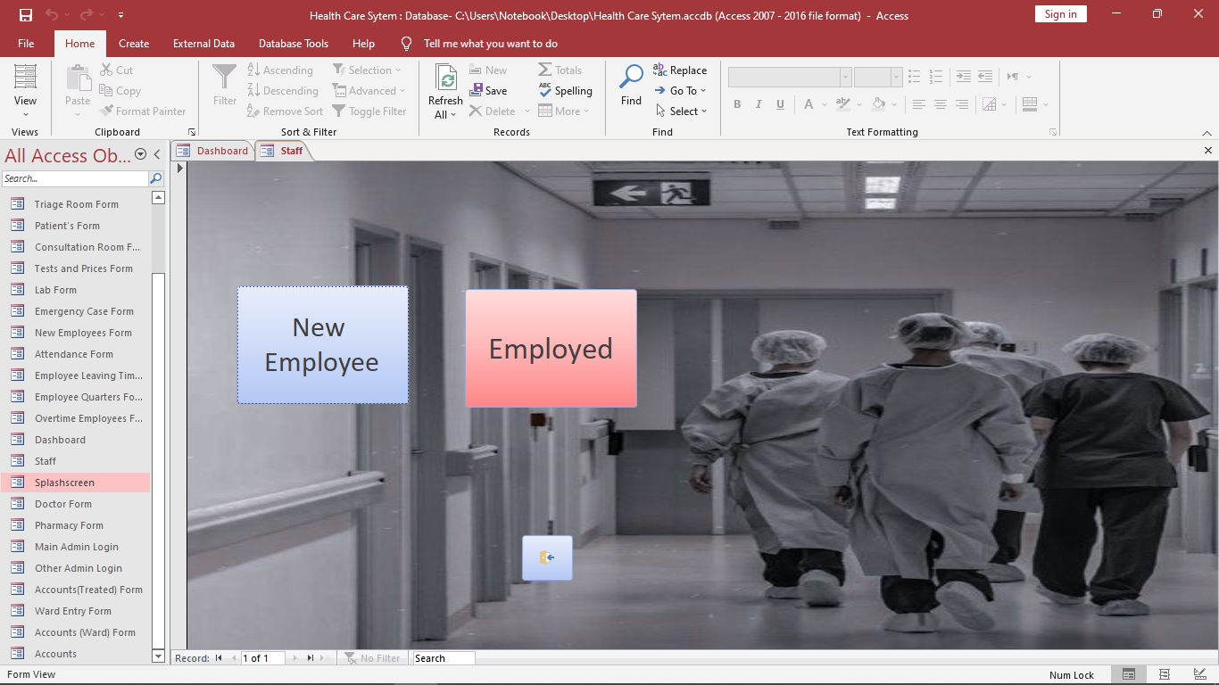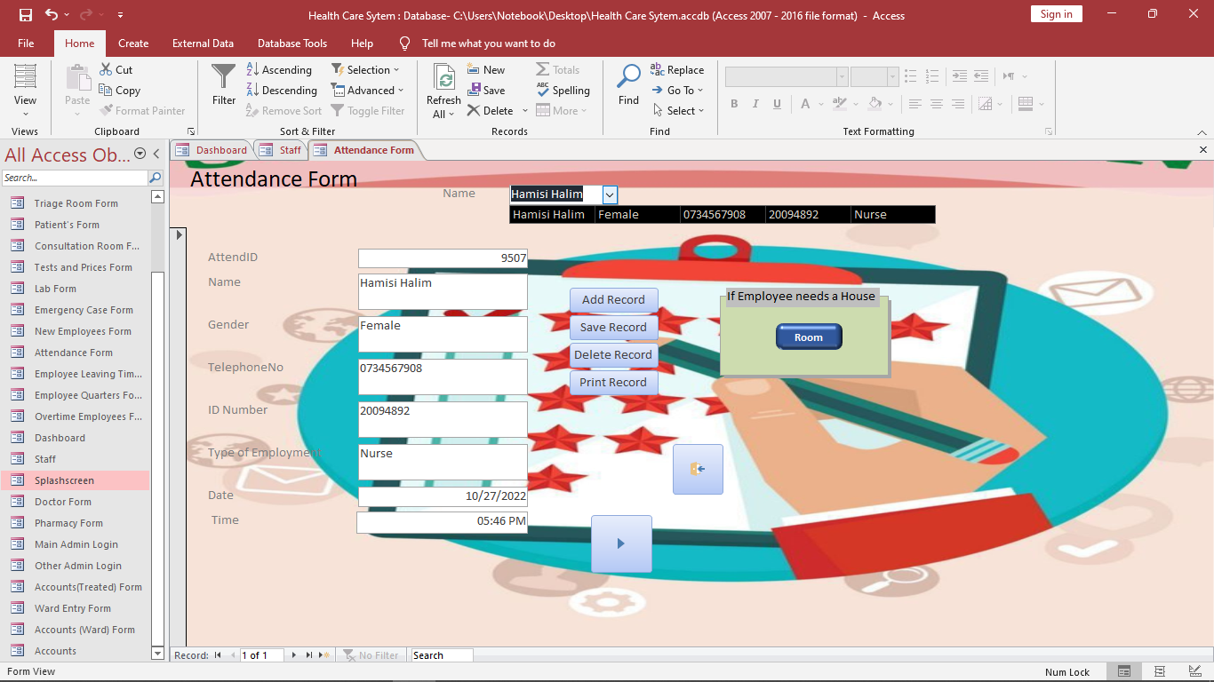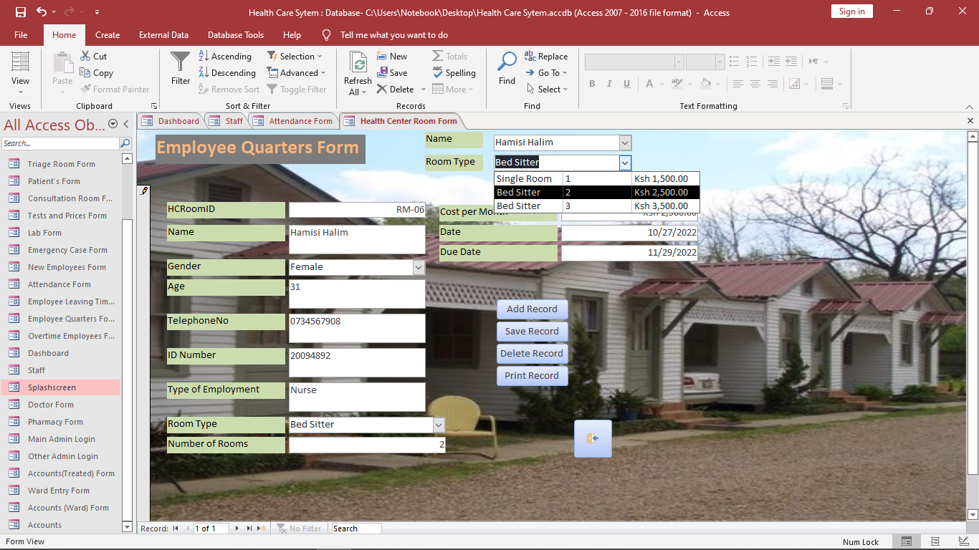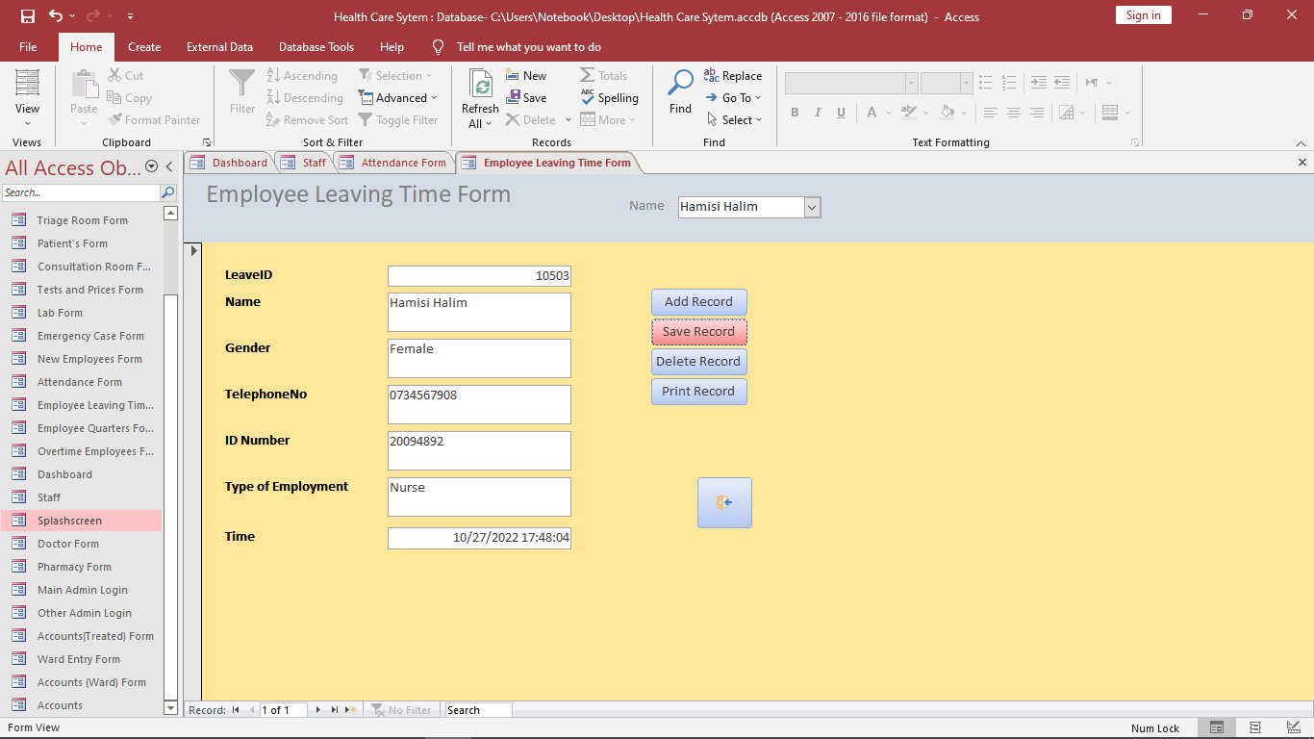

**Admin Section**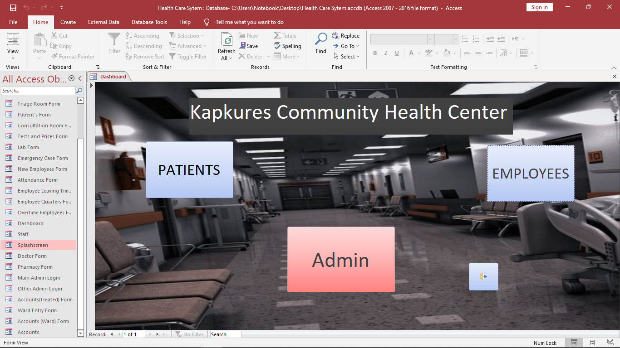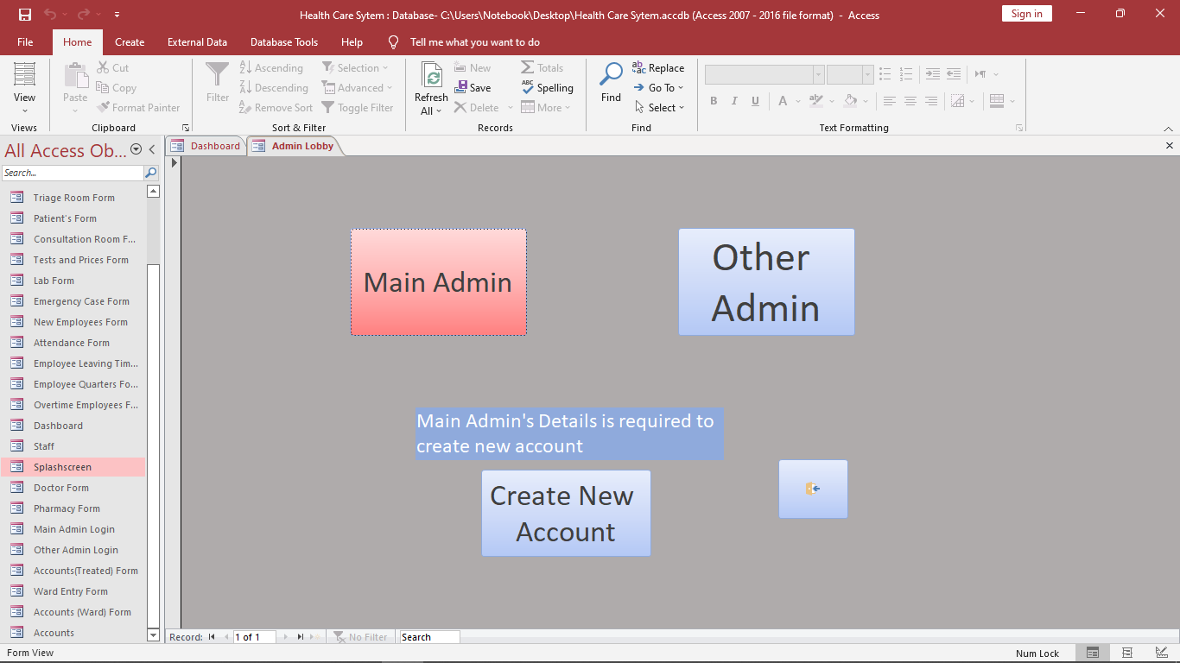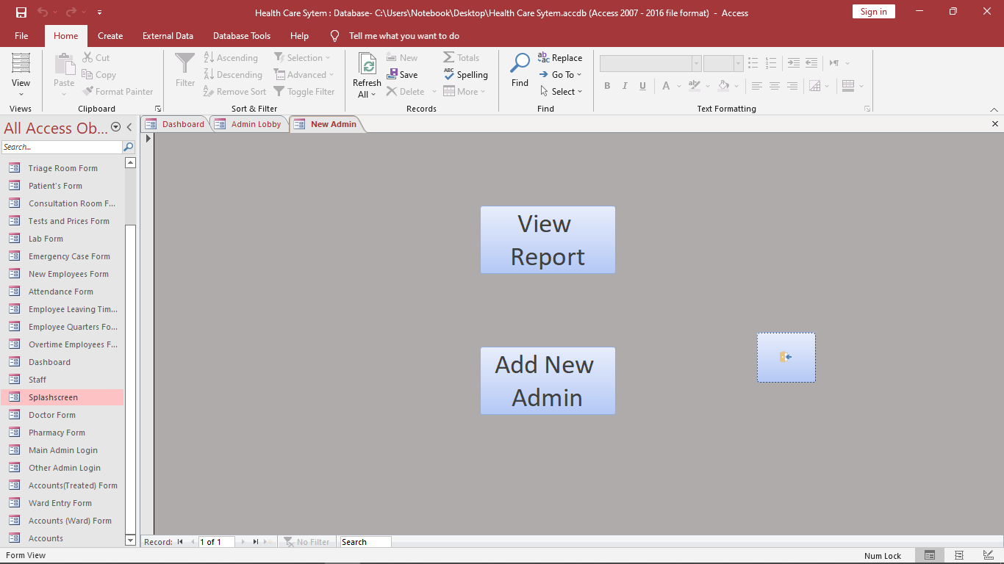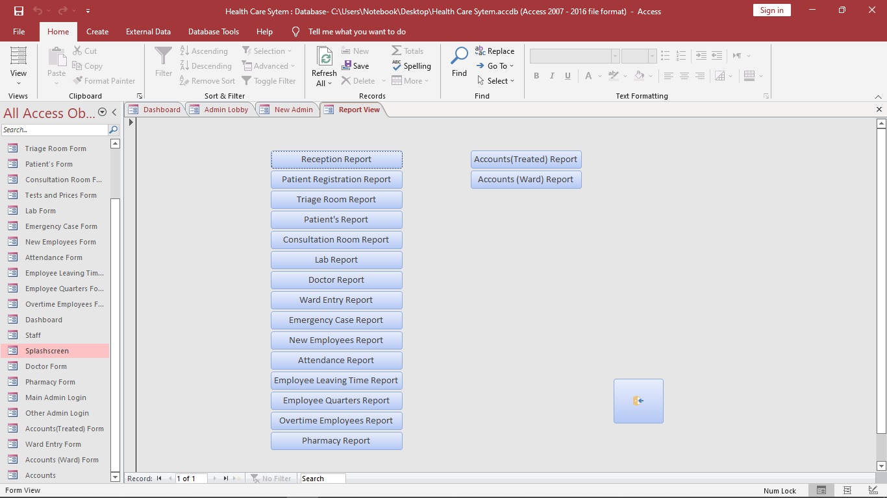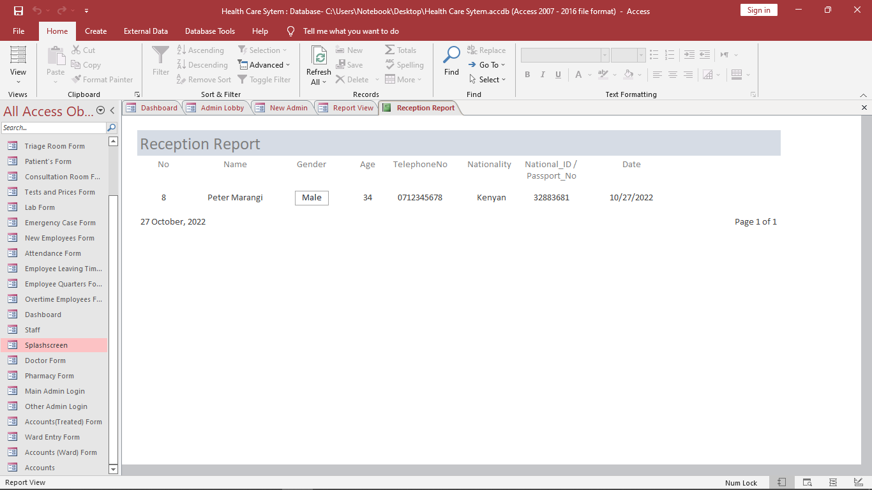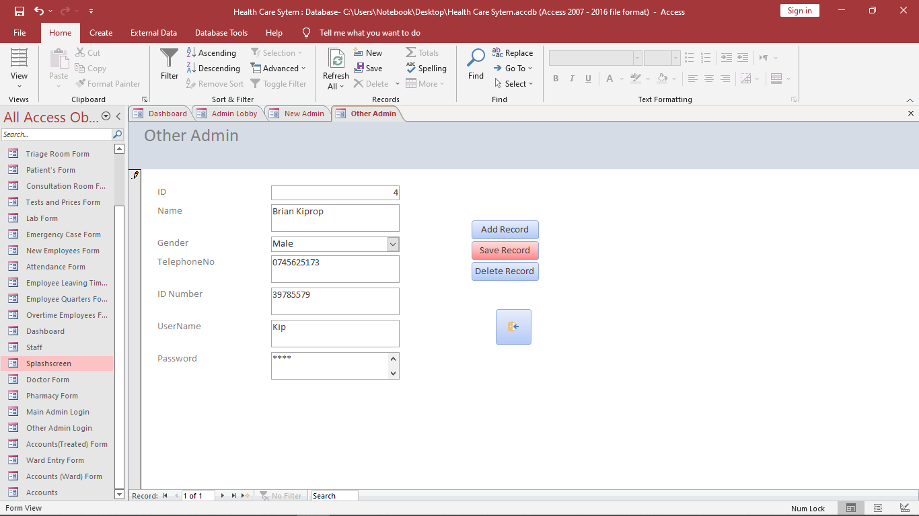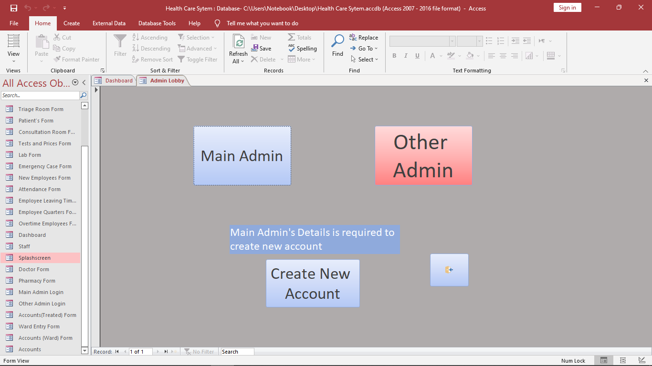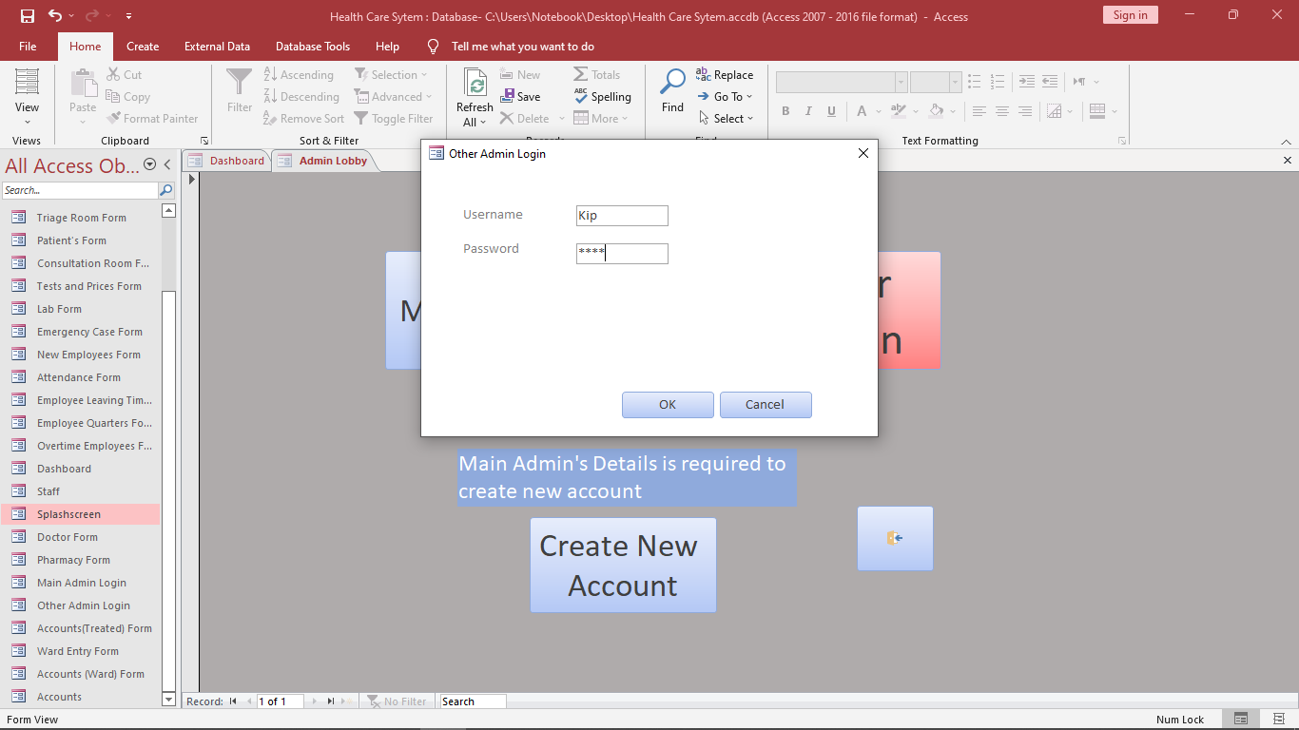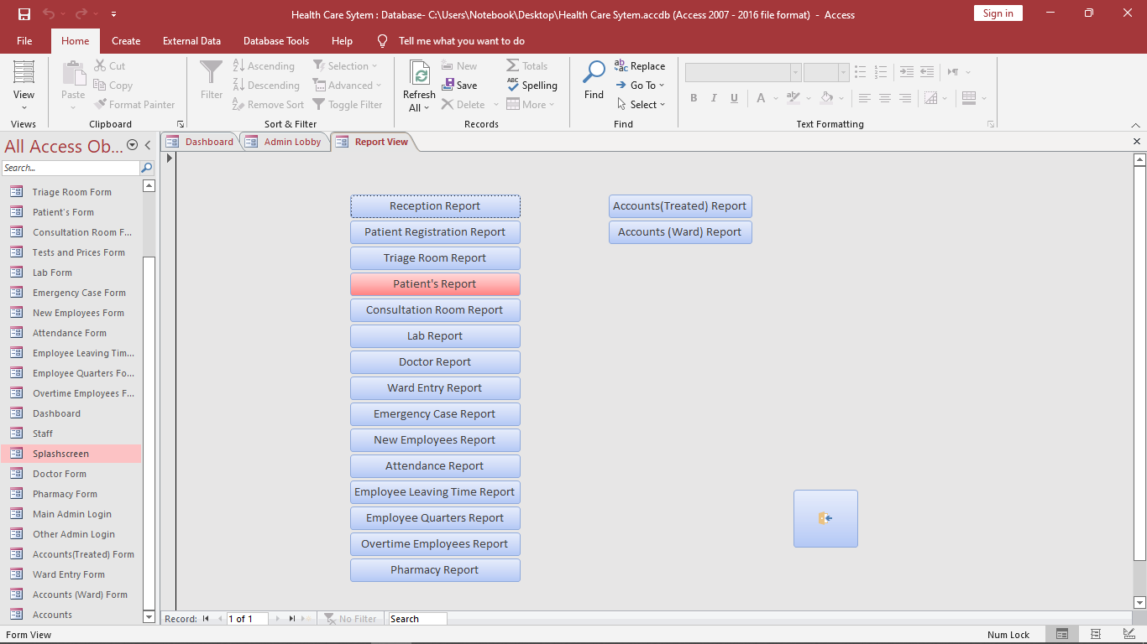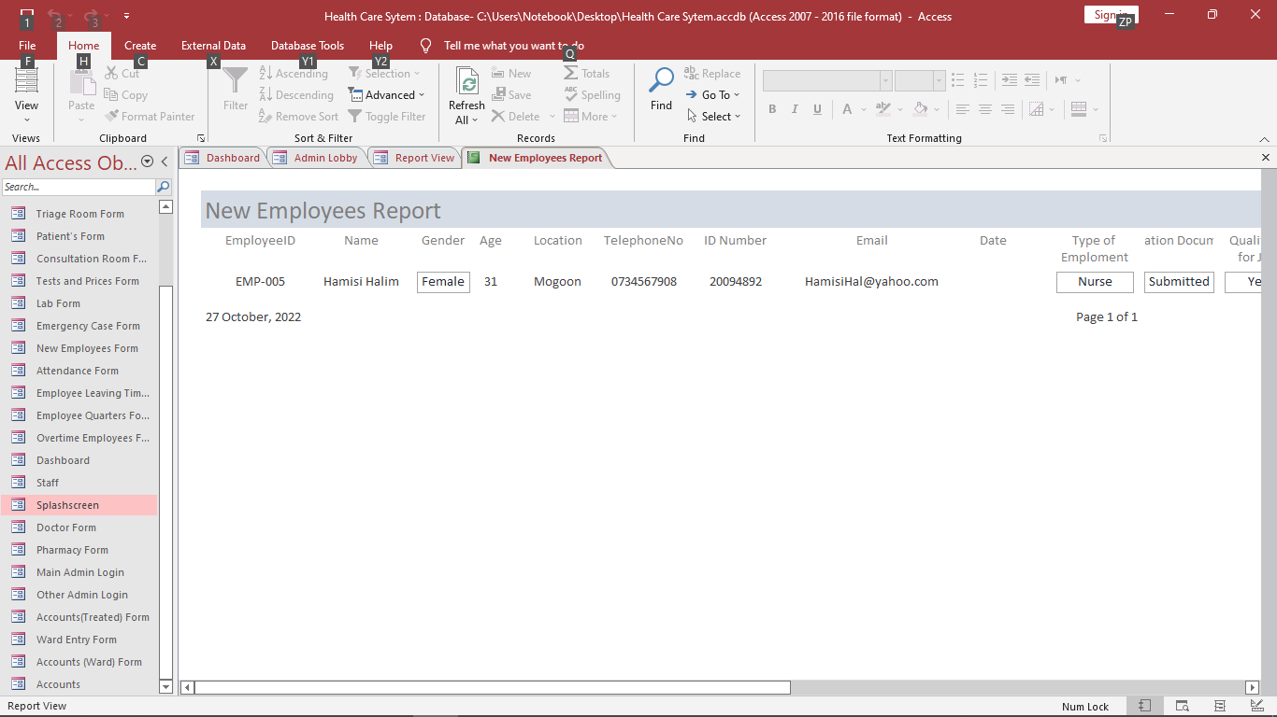

## **Testing Regime**

### **Tabulation of the test conducted**

During the software test and implementation, the software as a whole is tested to ensure that all its components work well together otherwise the application or the project cannot be said to be complete. If the test is successful, the software is then sent to the user to evaluate the software against their acceptance criteria. If the software satisfies these criteria, the application is put to use

### **Screenshot of the test**

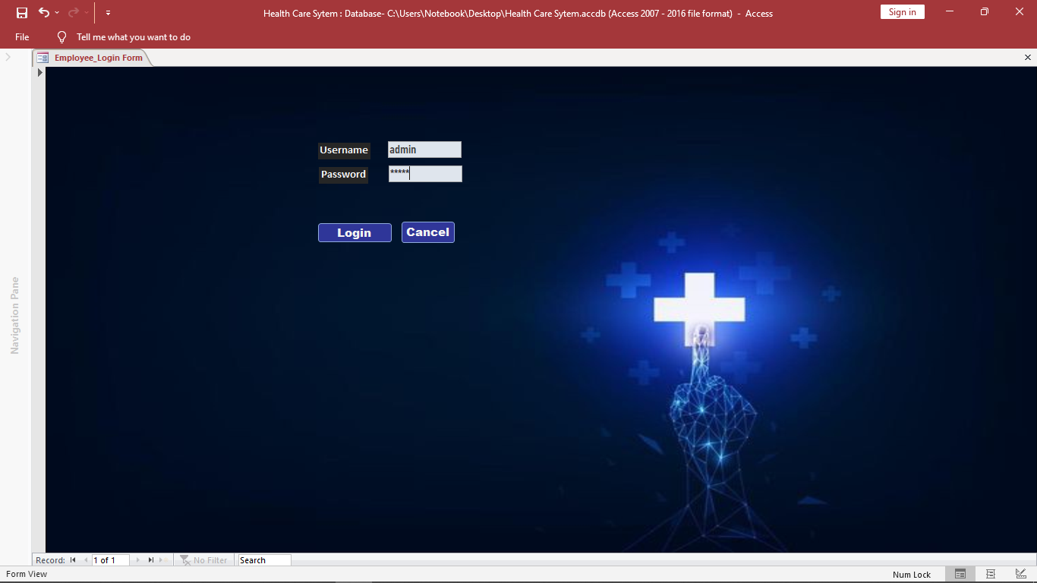

Figure : Login Module

# **CHAPTER SIX**

## **SYSTEM IMPLEMENTATIONS**

# **Introduction**

Implementation is the stage of the project when the theoretical design is turned out into a working system. Thus, it can be considered to be the most critical stage in achieving a successful new system and in giving the user, confidence that the new system will work and be effective.

The implementation stage involves careful planning, investigation of the existing system and its constraints on implementation, designing of methods to achieve changeover and evaluation of changeover methods.

## **Coding and testing**

The purpose of testing is to discover errors. Testing is the process of trying to discover every conceivable fault and weakness in a work product. It provides a way to check the functionality of components, sub-assemblies, assemblies and/or a finished product. It is the process of exercising software with the intent of ensuring that the software system meets its requirements and user expectations and does not fail in an unacceptable manner. There are various types of tests. Each test type addresses a specific testing requirement.

**TYPES OF TESTING**

**Unit testing:**

Unit testing involves the design of test cases that validate that the internal program logic is functioning properly, and that program inputs produce valid outputs. All decision branches and internal code flow should be validated. It is the testing of individual software units of the application. It is done after the completion of an individual unit for integration. This is a structural testing, that relies on knowledge of its construction and is invasive. Unit tests perform basic tests at component level and test a specific business process, application, and/or system configuration. Unit tests ensure that each unique path of a business process performs accurately to the documented specifications and contains clearly defined inputs and expected results.

**Integration testing:**

Integration tests are designed to test integrated software components to determine if they actually run as one program. Testing is event driven and is more concerned with the basic outcome of screens or fields. Integration tests demonstrate that although the components were individually satisfaction, as shown by successfully unit testing, the combination of components is correct and consistent. Integration testing is specifically aimed at exposing the problems that arise from the combination of components.

**Functional test:**

Functional tests provide systematic demonstrations that functions tested are specified by the business and technical requirements, system documentation, and user manuals.

Functional testing is centered on the following items:

Valid Input : identified classes of valid input must be accepted.

Invalid Input : identified classes of invalid input must be rejected.

Functions : identified functions must be exercised.

Output : identified classes of application outputs must be exercised.

Systems/Procedures : interfacing systems or procedures must be invoked.

Organization and preparation of functional tests is focused on requirements, key functions, or special test cases. In addition, systematic coverage pertaining to identify Business process flows; data fields, predefined processes, and successive process must be considered for testing. Before functional testing is complete, additional tests are identified and the effective value of current tests is determined.

**System Test:**

System Testing ensures that the entire integrated software system meets requirements. It tests a configuration to ensure known and predictable results. An example of system testing is the configuration-oriented system integration test. System Testing is based on process descriptions and flows, emphasizing pre-driven process links and integration points.

**White Box Testing:**

White Box Testing is a testing in which the software tester has knowledge of the inner workings, structure and language of the software, or at least its purpose. It is purpose, is used to test areas that cannot be reached from a black box level.

**Black Box Testing:**

This is testing the software without any knowledge of the inner workings, structure or language of the module being tested. Black box tests, as most other kinds of tests, must be written from a definitive source document, such as specification or requirements document, such as specification or requirements document. It is a testing in which the software under test is treated, as a black box. You cannot “see” into it. The test provides inputs and responds to outputs without considering how the software works.

**Unit testing:**

Unit Testing is usually conducted as part of a combined code and unit test phase of the software lifecycle, although it is not uncommon for coding and unit testing to be conducted as two distinct phases.

**Test strategy and approach**

Field testing will be performed manually and functional tests will be written in detail.

**Test objectives**

* All field entries must work properly.
* Pages must be activated from the identified link.
* The entry screen, messages and responses must not be delayed.

**Features to be tested**

* Verify that the entries are of the correct format.
* No duplicate entries should be allowed.
* All links should take the user to the correct page.

**Integration Testing:**

Software integration testing is the incremental integration testing of two or more integrated software components on a single platform to produce failures caused by interface defects.

The task of the integration test is to check that components or software applications, e.g., components in a software system or – one step up – software applications at the company level—interact without error.

**Test Results:**

All the test cases mentioned above passed successfully. No defects encountered.

**Acceptance Testing:**

User Acceptance Testing is a critical phase of any project and requires significant participation by the end user. It also ensures that the system meets the functional requirements.

**Test Results:**

All the test cases mentioned above passed successfully. No defects encountered.

## About the language

Microsoft Access is a database management System that is part of the Microsoft Office suite of productivity software. Visual Basic for Applications (VBA) is a programming language that is built into Microsoft Access. It can be used to automate tasks and add functionality to Access by creating custom programs and modules known as “macros”.

In a Microsoft Access Project, VBA can be used to create custom user interfaces such as forms and dialog boxes, which allow users to interact with the database in a more user-friendly way. VBA can also be used to manipulate database objects, such as tables and queries, and to work with data stored in the database.

Additionally, VBA can be used to create custom functions and procedures that can be used throughout the database. This allows developers to create reusable code that can be used in multiple places, making it easier to maintain and update the database.

## **Features of Visual Basic for Applications**

Some key features of Visual Basic for Applications (VBA) include the following:

1. **Object-oriented Programming:**

VBA is an object-oriented programming language, which means that it is based on the concept of “objects” that have properties and methods associated with them. This allows developers to create modular and reusable code that can be easily integrated into their Access projects.

1. **Built-in libraries:**

VBA includes a number of built-in libraries that provide access to a wide range of functionality, such as working with strings, dates and collections of data. This allows developers to quickly and easily perform common tasks without having to write their own code.

1. **Debugging tools:**

VBA includes a number of tools that can help developers troubleshoot and debug their code, such as the ability to step through code line by line and view the values of variables at different points in the execution of the program.

1. **Integration with Access:**

VBA is tightly integrated with Microsoft Access, which means that developers can easily access and manipulate database objects, such as tables and queries, from within their VBA code.

1. **Easy to learn:**

VBA is a relatively easy programming language to learn, especially for developers who are already familiar with the basics of programming. It is also well-documented, with a large number of online resources and tutorials available to help developers get started.

## **About the tools**

Visual Basic tools are a set of programming languages and tools that are used to develop and create applications in the Microsoft Access project. These tools are used to create user interfaces, control the flow of data and information, and create custom functions and routines within the project.

One of the key tools in Visual Basic for a Microsoft Access project is the Visual Basic Editor, which is used to write and edit code for the project. This tool allows users to create custom functions and routines, as well as to control the flow of data and information within the project.

Another important tool in Visual Basic for a Microsoft Access project is the forms designer, which is used to create user interfaces for the project. This tool allows users to design and customize the look and feel of the project, as well as to create custom buttons and controls for user interaction.

Other important tools in Visual Basic for a Microsoft Access project include the Reports Designer, which is used to create custom reports for the project, and the Debugger, which is used to troubleshoot and fix errors in the project’s code.

Overall, Visual Basic tools are essential for creating and developing applications in a Microsoft Access project, and are used to create user interfaces, control the flow of data and information, and create custom functions and routines within the project.

# **CHAPTER SEVEN**

## **CONCLUSIONS AND RECOMMENDATIONS**

# **Conclusion**

It was a wonderful learning experience for me while working on this project. This project took me through the various phases of project development and gave me real insight into the world of software engineering. I have developed an application thatallows entering details of the patient’s electronically in the “**INTEGRATED COMMUNITY DISPENSARY MANAGEMENT SYSTEM”,** data will be secured. Using this application, we can retrieve patient’s history with a single click. Thus, processing information will be faster. It guarantees accurate maintenance of patient details. It easily reduces the book keeping task and thus reduces the human effort and increases accuracy speed.

I did my best so that this project meets the stated aim and looking back at the aim it can be seen that the project has been completed given that it has met the aim.

# **Recommendations**

Technology is a solution to the many challenges facing people of the world. One of such challenge is delayed access to care and Services in many of the local dispensary this is because of the use of the Manual System. Integrated Community Dispensary Management System, I believe can be the much-needed solution to Health access in my community, Kenya and other parts of the world that have not implemented electronic model of this health care system.

# **REFERENCES**

1. Journal of Medical Systems

([https://link.springer.com/journal/10916](https://link.springer.com/journal/10916m))

1. Journal of the American Medical Informatics Association

([https://www.jamia.org/journal](https://www.jamia.org/journal6))

1. The Seven Phases of the System-Development Life Cycle

[Online]Available at:

(<https://www.tutorialspoint.com/sdlc/sdlc_agile_model.htm>)

1. “*Programming with Microsoft Visual Basic 2017”* by Diane Zak
2. “*Mastering Visual Basic 2017”* by Evangelos Petroutsos
3. Goh, K., & Bostrom, p.(2018). An evaluation of the impact of a dispensary management system on medication errors, dispensing times, and workload in a hospital outpatient pharmacy. International Journal of clinical Pharmacy, 40(5), 899-906

# **APPENDICES**

## **APPENDIX 1: WORKPLAN**

|  |  |
| --- | --- |
| **Weeks** | **Description of work done** |
| Week one | Doing research about the project and coming up of the appropriate tittle of the project |
| Week two | System functional requirements |
| Week three | Data Structures & Database design (Back-end design) |
| Week four | Front end design or Graphical User Interface |
| Week five | System Coding and Documentation |

Figure 11: Workplan

## **APPENDIX 2: System Codes**

***Form Accounts (Ward) Form***

***Private Sub cboWardID_Change()***

***Me.txtFirstName.Value = Me.cboWardID.Column(1)***

***Me.txtSurname.Value = Me.cboWardID.Column(2)***

***Me.txtGender.Value = Me.cboWardID.Column(3)***

***Me.txtLab_Test.Value = Me.cboWardID.Column(4)***

***Me.txtCost.Value = Me.cboWardID.Column(5)***

***Me.txtDecision.Value = Me.cboWardID.Column(6)***

***Me.txtWard_Type.Value = Me.cboWardID.Column(7)***

***Me.txtCost_Per_Day.Value = Me.cboWardID.Column(8)***

***Me.txtNumber_of_Days.Value = Me.cboWardID.Column(9)***

***End Sub***

***Form Accounts (Treated) Form***

***Private Sub cboPharmacyID_Change()***

***Me.txtFirstName.Value = Me.cboPharmacyID.Column(1)***

***Me.txtSurname.Value = Me.cboPharmacyID.Column(2)***

***Me.txtGender.Value = Me.cboPharmacyID.Column(3)***

***Me.txtLab_Test.Value = Me.cboPharmacyID.Column(4)***

***Me.txtCosts.Value = Me.cboPharmacyID.Column(5)***

***Me.txtPatient_Treated.Value = Me.cboPharmacyID.Column(6)***

***Me.txtMedicine_Category.Value = Me.cboPharmacyID.Column(7)***

***Me.txtMedicine.Value = Me.cboPharmacyID.Column(8)***

***Me.txtCost.Value = Me.cboPharmacyID.Column(9)***

***End Sub***

***Form Attendance Form***

***Private Sub cboEmloyeeID_Change()***

***Me.txtName.Value = Me.cboEmloyeeID.Column(1)***

***Me.txtGender.Value = Me.cboEmloyeeID.Column(2)***

***Me.txtTelephoneNo.Value = Me.cboEmloyeeID.Column(3)***

***Me.txtID_Number.Value = Me.cboEmloyeeID.Column(4)***

***Me.txtType_of_Employment.Value = Me.cboEmloyeeID.Column(5)***

***End Sub***

***Form Consultation Room Form***

***Private Sub cboTriageID_Change()***

***Me.txtFirst_Name.Value = Me.cboTriageID.Column(1)***

***Me.txtSecondName.Value = Me.cboTriageID.Column(2)***

***Me.txtSurname.Value = Me.cboTriageID.Column(3)***

***Me.txtGender.Value = Me.cboTriageID.Column(4)***

***Me.txtAge.Value = Me.cboTriageID.Column(5)***

***Me.txtTemperature.Value = Me.cboTriageID.Column(6)***

***Me.txtBlood_Presure.Value = Me.cboTriageID.Column(7)***

***Me.txtOxygen_Saturation.Value = Me.cboTriageID.Column(8)***

***Me.txtWeight_kg_.Value = Me.cboTriageID.Column(9)***

***Me.txtHeight_ft_.Value = Me.cboTriageID.Column(10)***

***End Sub***

***Form Doctor Form***

***Private Sub cboLabID_Change()***

***Me.txtFirstName.Value = Me.cboLabID.Column(1)***

***Me.txtSurname.Value = Me.cboLabID.Column(2)***

***Me.txtGender.Value = Me.cboLabID.Column(3)***

***Me.txtLab_Test.Value = Me.cboLabID.Column(4)***

***Me.txtCost.Value = Me.cboLabID.Column(5)***

***Me.txtLab_Result.Value = Me.cboLabID.Column(6)***

***End Sub***

***Form Emergency Case Form***

***Private Sub cboWardID_Change()***

***Me.txtFirstName.Value = Me.cboWardID.Column(1)***

***Me.txtSurname.Value = Me.cboWardID.Column(2)***

***Me.txtGender.Value = Me.cboWardID.Column(3)***

***Me.txtLab_Test.Value = Me.cboWardID.Column(4)***

***Me.txtLab_Result.Value = Me.cboWardID.Column(5)***

***End Sub***

***Form Employee Leaving Time Form***

***Private Sub cboAttendID_Change()***

***Me.txtName.Value = Me.cboAttendID.Column(1)***

***Me.txtGender.Value = Me.cboAttendID.Column(2)***

***Me.txtTelephoneNo.Value = Me.cboAttendID.Column(3)***

***Me.txtID_Number.Value = Me.cboAttendID.Column(4)***

***Me.txtType_of_Employment.Value = Me.cboAttendID.Column(5)***

***End Sub***

***Form Employee Quarters Form***

***Private Sub cboEmployeeID_Change()***

***Me.txtName.Value = Me.cboEmployeeID.Column(1)***

***Me.txtGender.Value = Me.cboEmployeeID.Column(2)***

***Me.txtAge.Value = Me.cboEmployeeID.Column(3)***

***Me.txtTelephoneNo.Value = Me.cboEmployeeID.Column(4)***

***Me.txtID_Number.Value = Me.cboEmployeeID.Column(5)***

***Me.txtType_of_Employment.Value = Me.cboEmployeeID.Column(6)***

***End Sub***

***Private Sub cboID_Change()***

***Me.txtRoom_Type.Value = Me.cboID.Column(1)***

***Me.txtNumber_of_Rooms.Value = Me.cboID.Column(2)***

***Me.txtCost_per_Month.Value = Me.cboID.Column(3)***

***End Sub***

***Form Employee login Form***

***Private Sub Command8_Click()***

***If IsNull(Me.txtUserName) Then***

***MsgBox "Please enter Username", vbInformation, "Username required"***

***Me.txtUserName.SetFocus***

***ElseIf IsNull(Me.txtpassword) Then***

***MsgBox "Please enter your password", vbInformation, "Password Required"***

***Me.txtpassword.SetFocus***

***Else***

***'process the job***

***If (IsNull(DLookup("Username", "Employee_Login", "Username='" & Me.txtUserName.Value & "'"))) Or _***

***(IsNull(DLookup("Password", "Employee_Login", "Password='" & Me.txtpassword.Value & "'"))) Then***

***MsgBox "Incorrect Username or Password"***

***Else***

***'MsgBox "Username and password correct"***

***DoCmd.Close***

***DoCmd.OpenForm "Dashboard"***

***End If***

***End If***

***End Sub***

***Form lab form***

***Private Sub cboConsultationID_Change()***

***Me.txtFirstName.Value = Me.cboConsultationID.Column(1)***

***Me.txtSurname.Value = Me.cboConsultationID.Column(2)***

***Me.txtGender.Value = Me.cboConsultationID.Column(3)***

***End Sub***

***Private Sub cboTestID_Change()***

***Me.txtLab_Test.Value = Me.cboTestID.Column(1)***

***Me.txtCost.Value = Me.cboTestID.Column(2)***

***End Sub***

***Form Main Admin Login***

***Private Sub Command1_Click()***

***If IsNull(Me.txtUserName) Then***

***MsgBox "Please enter UserName", vbInformation, "UserName Required"***

***Me.txtUserName.SetFocus***

***ElseIf IsNull(Me.txtpassword) Then***

***MsgBox "Please enter password", vbInformation, "Password Required"***

***Me.txtpassword.SetFocus***

***Else***

***'process the job***

***If (IsNull(DLookup("UserName", "Main Admin", "UserName ='" & Me.txtUserName.Value & "'"))) Or _***

***(IsNull(DLookup("Password", "Main Admin", "password ='" & Me.txtpassword.Value & "'"))) Then***

***MsgBox "Incorrect UserName or Password"***

***Else***

***'MsgBox "UserName and Password Correct"***

***DoCmd.Close***

***DoCmd.OpenForm "New Admin"***

***End If***

***End If***

***End Sub***

***Form other Admin Login***

***Private Sub Command1_Click()***

***If IsNull(Me.txtUserName) Then***

***MsgBox "Please enter UserName", vbInformation, "UserName Required"***

***Me.txtUserName.SetFocus***

***ElseIf IsNull(Me.txtpassword) Then***

***MsgBox "Please enter password", vbInformation, "Password Required"***

***Me.txtpassword.SetFocus***

***Else***

***'process the job***

***If (IsNull(DLookup("UserName", "Other Admin", "UserName ='" & Me.txtUserName.Value & "'"))) Or _***

***(IsNull(DLookup("Password", "Other Admin", "password ='" & Me.txtpassword.Value & "'"))) Then***

***MsgBox "Incorrect UserName or Password"***

***Else***

***'MsgBox "UserName and Password Correct"***

***DoCmd.Close***

***DoCmd.OpenForm "Report View"***

***End If***

***End If***

***End Sub***

***Form Overtime Employees form***

***Private Sub cboEmployeeID_Change()***

***Me.txtName.Value = Me.cboEmployeeID.Column(1)***

***Me.txtGender.Value = Me.cboEmployeeID.Column(2)***

***Me.txtAge.Value = Me.cboEmployeeID.Column(3)***

***Me.txtTelephoneNo.Value = Me.cboEmployeeID.Column(4)***

***Me.txtID_Number.Value = Me.cboEmployeeID.Column(5)***

***Me.txtType_of_Employment.Value = Me.cboEmployeeID.Column(6)***

***End Sub***

***Private Sub cboOTPayID_Change()***

***Me.txtJob_Category.Value = Me.cboOTPayID.Column(1)***

***Me.txtPayment_Per_day.Value = Me.cboOTPayID.Column(2)***

***End Sub***

***Form Patient’s form***

***Private Sub cboPatientID_Change()***

***Me.txtFirstName.Value = Me.cboPatientID.Column(1)***

***Me.txtSecondName.Value = Me.cboPatientID.Column(2)***

***Me.txtSurname.Value = Me.cboPatientID.Column(3)***

***Me.txtGender.Value = Me.cboPatientID.Column(4)***

***Me.txtAge.Value = Me.cboPatientID.Column(5)***

***Me.txtTelephoneNo.Value = Me.cboPatientID.Column(6)***

***Me.txtDOB.Value = Me.cboPatientID.Column(7)***

***Me.txtEmail.Value = Me.cboPatientID.Column(8)***

***End Sub***

***Form Pharmacy form***

***Private Sub cboDocID_Change()***

***Me.txtFirstName.Value = Me.cboDocID.Column(1)***

***Me.txtSurname.Value = Me.cboDocID.Column(2)***

***Me.txtGender.Value = Me.cboDocID.Column(3)***

***Me.txtLab_Test.Value = Me.cboDocID.Column(4)***

***Me.txtCosts.Value = Me.cboDocID.Column(5)***

***Me.txtLab_Result.Value = Me.cboDocID.Column(6)***

***Me.txtDecision.Value = Me.cboDocID.Column(7)***

***Me.txtPatient_Treated.Value = Me.cboDocID.Column(8)***

***Me.txtMedicine_requested.Value = Me.cboDocID.Column(9)***

***End Sub***

***Private Sub cboStoreID_Change()***

***Me.txtMedicine_Category.Value = Me.cboStoreID.Column(1)***

***Me.txtMedicine.Value = Me.cboStoreID.Column(2)***

***Me.txtCost.Value = Me.cboStoreID.Column(3)***

***End Sub***

***Form Splash screen***

***Private Sub Form_Timer()***

***Me.lblcount.Caption = Me.lblcount.Caption + 1***

***Me.lblprogress.Width = Me.lblprogress.Width + 60***

***If Me.lblcount.Caption = 100 Then***

***DoCmd.Close***

***DoCmd.OpenForm "Employee_Login Form", acNormal***

***End If***

***End Sub***

***Form Triage Room form***

***Private Sub cboPatientID_Change()***

***Me.txtFirst_Name.Value = Me.cboPatientID.Column(1)***

***Me.txtSecondName.Value = Me.cboPatientID.Column(2)***

***Me.txtSurname.Value = Me.cboPatientID.Column(3)***

***Me.txtGender.Value = Me.cboPatientID.Column(4)***

***Me.txtAge.Value = Me.cboPatientID.Column(5)***

***End Sub***

***Form Ward Entry form***

***Private Sub cboDocID_Change()***

***Me.txtFirstName.Value = Me.cboDocID.Column(1)***

***Me.txtSurname.Value = Me.cboDocID.Column(2)***

***Me.txtGender.Value = Me.cboDocID.Column(3)***

***Me.txtLab_Test.Value = Me.cboDocID.Column(4)***

***Me.txtCost.Value = Me.cboDocID.Column(5)***

***Me.txtLab_Result.Value = Me.cboDocID.Column(6)***

***Me.txtDecision.Value = Me.cboDocID.Column(7)***

***End Sub***

***Private Sub cboID_Change()***

***Me.txtWard_Type.Value = Me.cboID.Column(1)***

***Me.txtCost_Per_Day.Value = Me.cboID.Column(2)***

***End Sub***

## **APPENDIX 3: QUESTIONNAIRES**

1. How do you find this system?

Poor

Fair

Very good

Excellent

1. How is the operation?

Complicated

Interesting

Easy

1. What do you think should be improved?

Others (specify)………

Build a new system

The current (old) system

1. Do you find this (new system) relevant and helpful?

No

Yes

1. What would you like added in this system...

…………………………………………………………………………………

…………………………………………………………………………………

…………………………………………………………………………………

1. Do you like the graphic presentation of the system?

No

Yes

1. Do you recommend others to use this system?

Yes

No

1. Is the system readily available in your area?

Sometimes

Always

1. What impact does the system have on you?

Other (specify)………………

Negative

Positive

Personal remarks…………………………………………………………………………

……………………………………………………………………………………………

……………………………………………………………………………………………

……………………………………………………………………………………………